
7686 W. 88th Ave * Arvada, CO 80005
✉ sambrown@brown-associates.com
📞303-938-9946
LAKEWOOD CROSSING PAD SITE
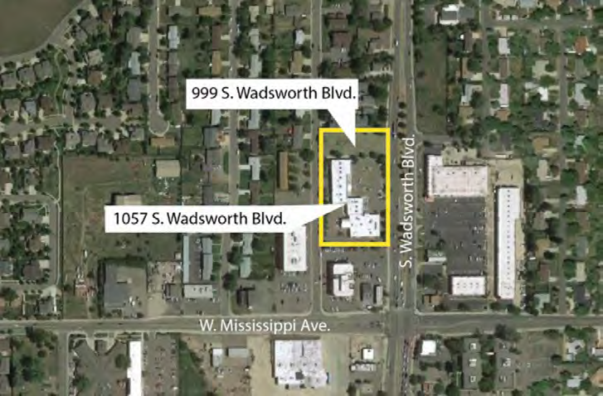
Located at 999 South Wadsworth, Lakewood, Colorado 80027. Approximately 27,000 Square feet pad site
Part of Lakewood Crossing which currently has approval for a 2,850 square foot building with a drive through.
The approved Site Plan may be changed.
Approximately 59,000 vehicles per day pass the property.
Owner will ground lease or sell. Sale price $675,000
Sam Brown
Brown & Associates
✉ sambrown@brown-associates.com
📞: 303-938-9946

