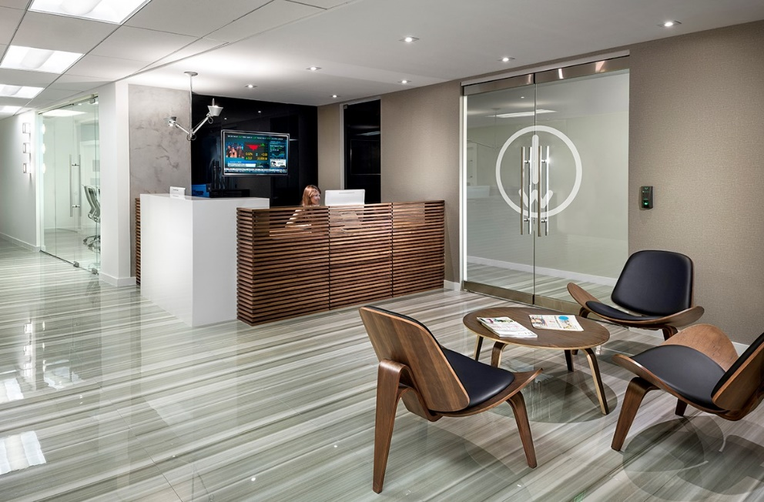
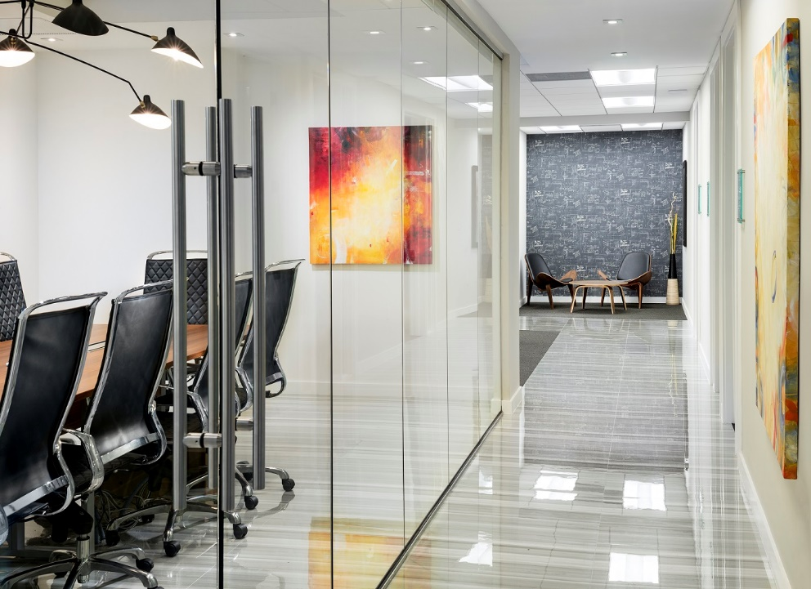
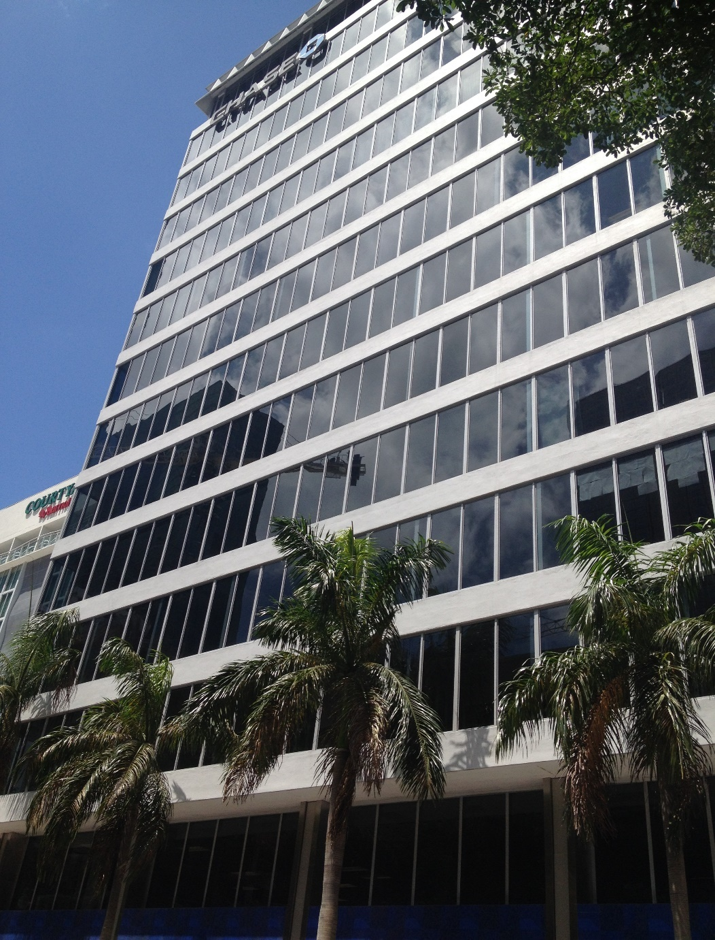
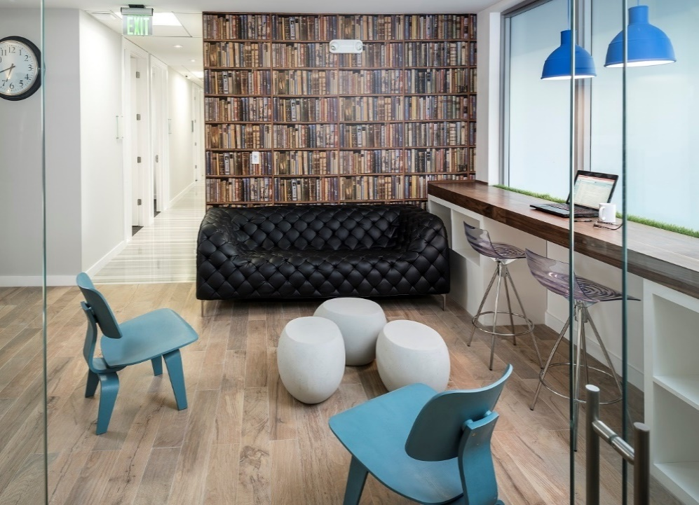
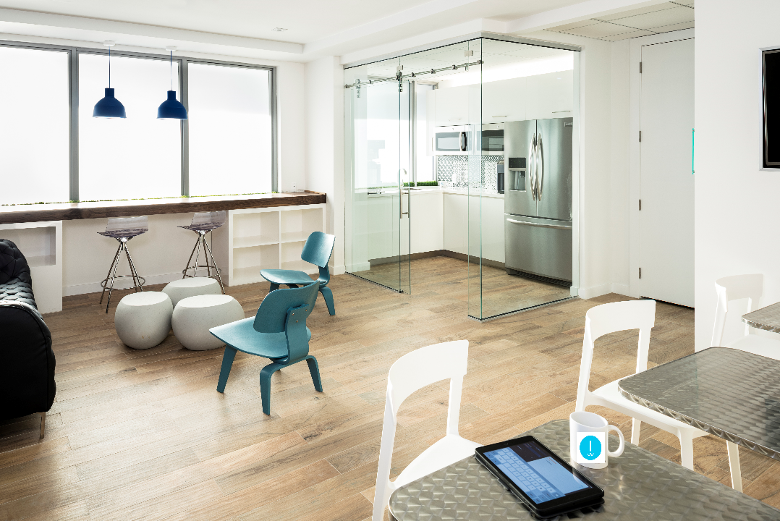

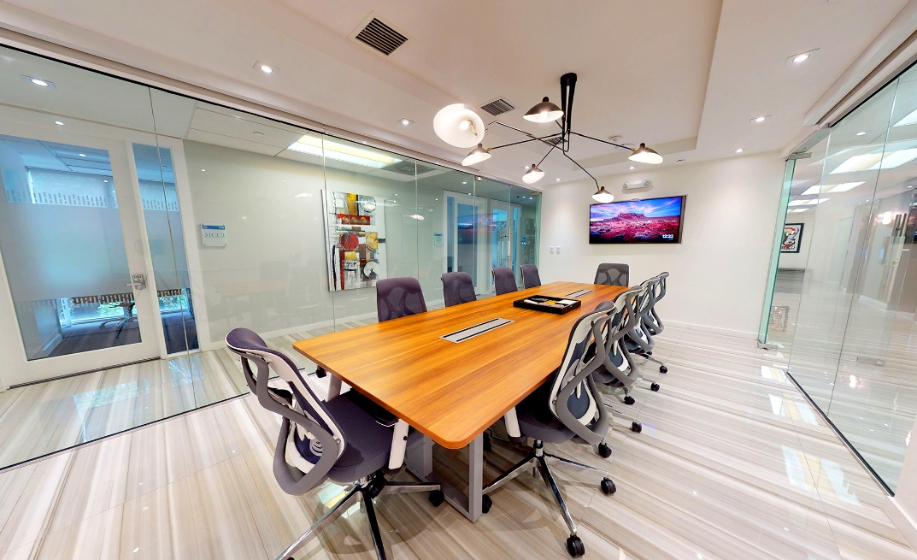
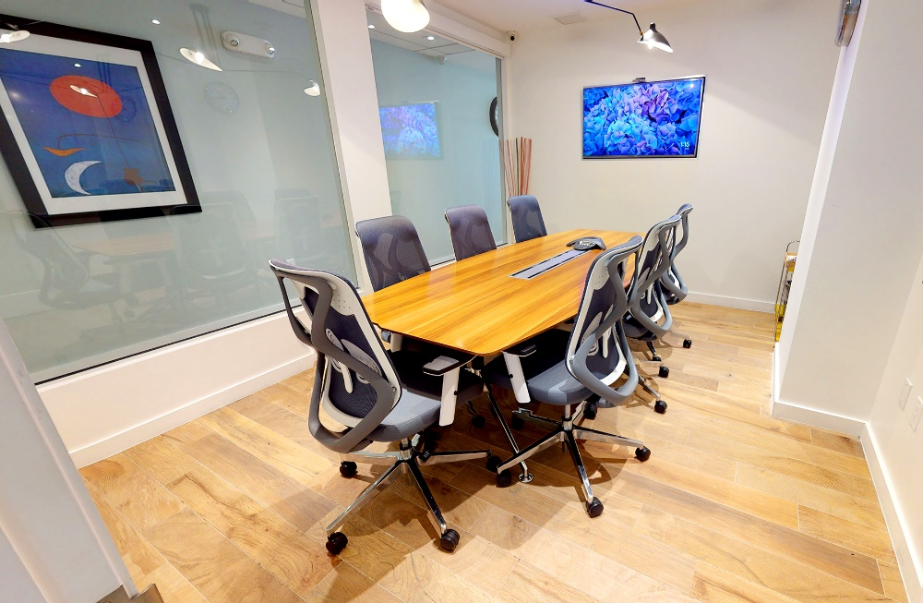

Suite # | Description | Monthly price
331 | Natural Light Office 1-3 desks | $ 1,097.00
PRIVATE OFFICE

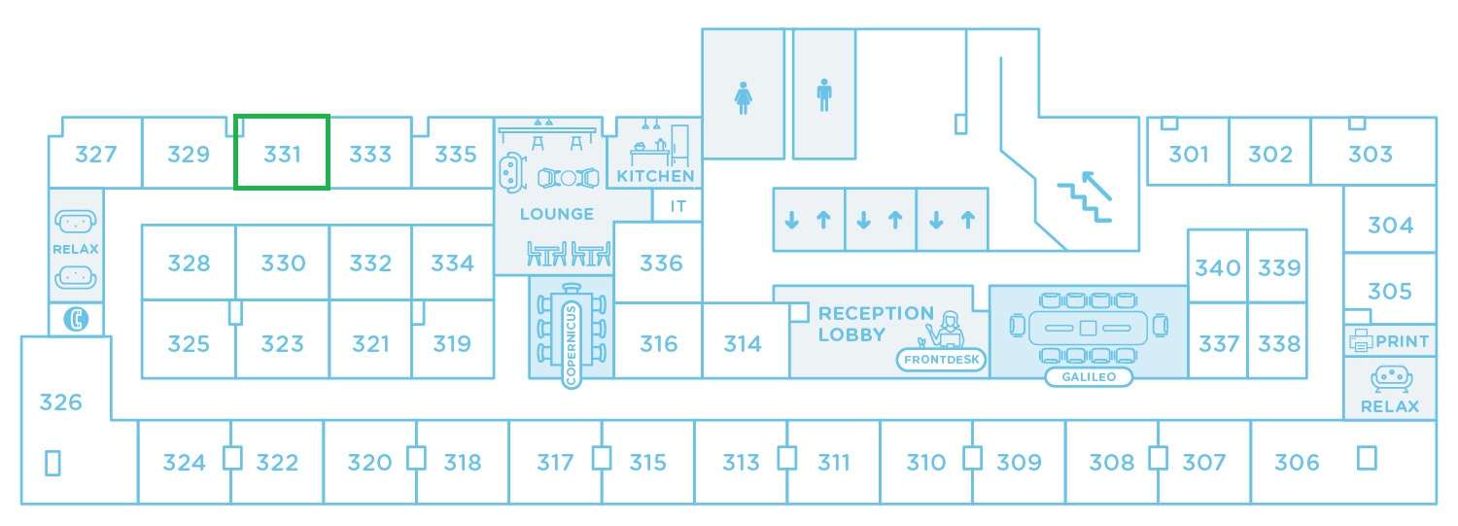

OFFICE MOVE IN COST BREAKDOWN
OFFICE COST SUMMARY - suite 331
Item | one-time fees | monthly fee | Initial Payment
REFUNDABLE SECURITY OFFICE DEPOSIT | $ 1,097.00
ONE-TIME OFFICE SETUP FEE | $99.00
OFFICE MONTHLY FEE |  | $ 1,097.00
TOTAL | $ 1,196.00 | $ 1,097.00 | $ 2,293.00

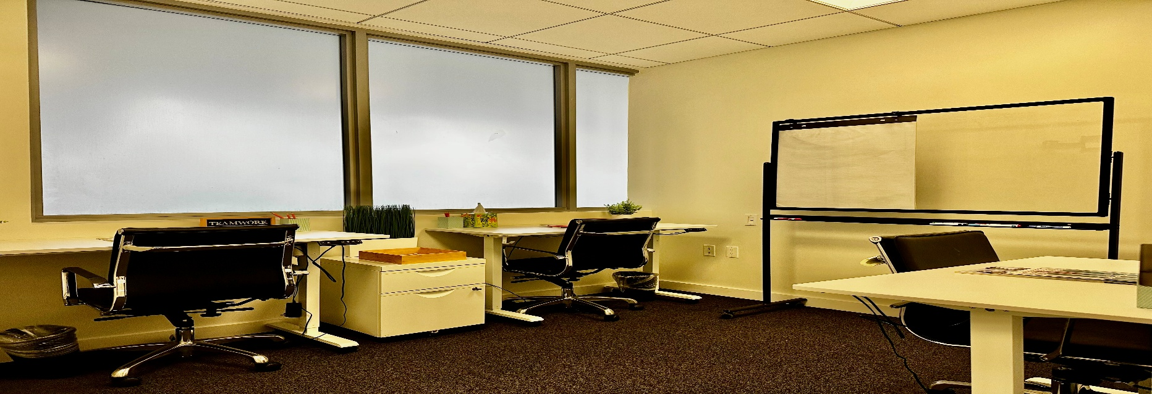

Security Deposit: 1 month - Refundable at the end of contract or can be applied to your last invoice payment.

Office Setup Fee: $99 per office to cover building code programming of 24/7 access, door code keypad programming, logo door installation, Private VLan setup, Add company name on center lobby directory.

Included in the monthly private office fee are the following services:
- Access 24/7
- FIBER Internet Access on your own secure VLAN
- Office Furniture
- Bilingual receptionist to welcome your visitors, receive your mail and packages.
- Lounge area with complementary beverages
- Access to Member Portal and Networking Events
- Janitorial services & Utilities (Air Conditioner, Electricity, Water)
- 4 FREE Hours per office per month for Meeting Room Copernicus up to 8 people capacity
- Discounted rates to conference rooms, admin, secretarial and copying services

Parking
Monthly Parking: $160 per month
Visitors Valet Parking: $6 per 30 minutes / $12 per hour / $12 early bird day rate (if arrive before 9:30am) / $25 per day

DIRECTIONS
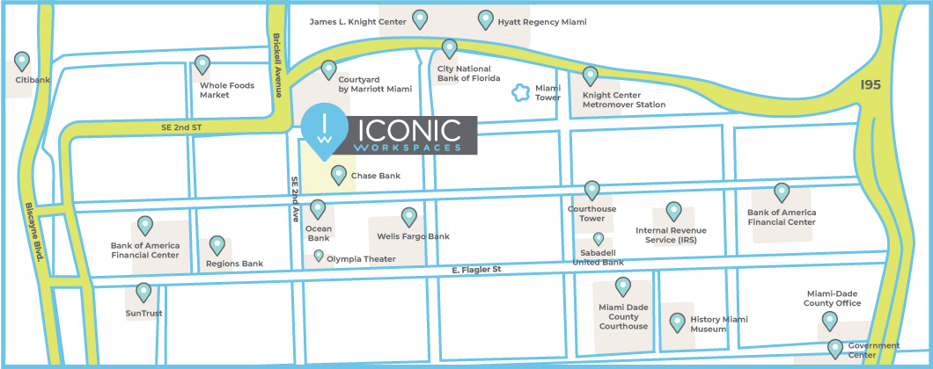
From I-395 East, take exit 2A toward US-1 on Biscayne Blvd (3/4 of a mile). Turn right on NE 2nd Ave toward SE 2nd Street and you will find Chase Bank to your right-hand side with a private modern entrance following it. ICONIC Workspaces is located on the 3rd floor of CHASE Building #150. You may self-park on the street or opt to valet inside the building garage.
From Miami International Airport:
Take I-395 East to exit 2A on the left toward US-1, Biscayne Blvd. Turn right onto NE 2nd Ave and continue straight ahead toward SE 2nd Street, where Chase Building #150 is located on your right. Turn right to park at the garage valet parking inside the building.
From Ft. Lauderdale International Airport:
Take I-95 South toward Downtown and keep left to merge onto I-395 East toward Port Miami, Miami Beach. Take exit 2B toward Biscayne Blvd and turn right onto NE 2nd Ave. In less than a mile, on the SE 2nd Street, Chase Building #150 is on your right. Turn right to park at the garage valet parking inside the building.
From the Beaches:
Begin on 5th street and take exit 2 toward Biscayne Blvd. Turn right onto NE 7th St. and then turn left onto NE 2nd Ave. In less than a mile, on the SE 2nd Street, Chase Building #150 is on your right. Turn right to park at the garage valet parking inside the building.
PUBLIC TRANSPORTATION
Coming from Miami International Airport take the Southbound Orange Line Metrorail, ride to Earlington Heights station. Transfer and take Southbound Green Line Metrorail to Government Center station. Ride the free Metromover to the Knight Center by taking the Inner Loop route.
Coming from inside Downtown Miami ride the free Metromover and take the Inner Loop route to the Knight Center station and follow the signs for NE 2nd Ave.
OR ride the free Biscayne Trolley toward SE 2nd Street.
Coming from Miami Beach board the Metrobus 119 Route Southbound toward Downtown Miami. Exit bus at NE 3 St & NE 2 Ave.
Coming from South board the Metrorail Orange Line train Northbound toward Miami International Airport. Exit train at Government Center and transfer to Metromover. Board the Metromover Omni Loop monorail. Exit monorail at Knight Center.
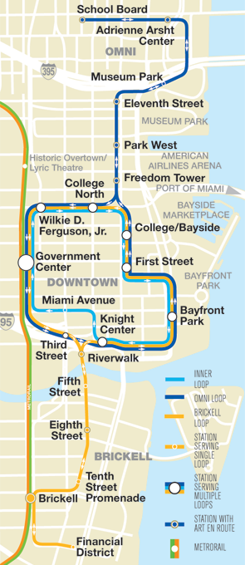
Coming from North board BCT US1 Breeze bus Southbound toward Aventura Mall. Exit bus at Aventura Mall and board the Metrobus 93 Biscayne MAX Southbound toward Downtown. Exit bus at NE 3 St & NE 2 Ave.
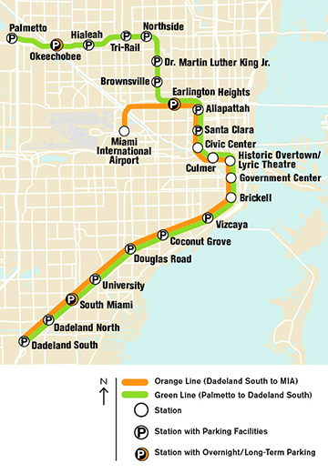

We are here
MetroRail Stop
MetroMover Stop

