
MACKINTOSH, Inc.
For Lease – Former Gym Suite
$14 SF + NNN ($3.55 SF)

COMMERCIAL BROKERAGE

Hartz Building Warehouse / Office
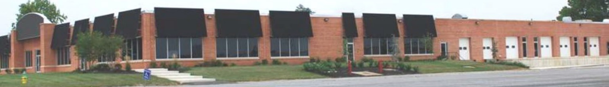
1341 Hughes Ford Road, Frederick, Maryland 21701

The Hartz Building is located Adjacent to Frederick Airport and contains a mixed use of Warehouse and Office Space. Suites are available with Drive-In or Dock Doors. Join other Tenants: Rehab2 Perform, X Factor Fitness, Dragon Distillery, That Auto Shop, and Bay Runner Shuttle.

Suites Available:
Hartz Suite 110 – 3,849 SF
Click Here for Inside Video of Suite 110
Large Rectangular Suite with a Drive-In Door. Suite 110 consists of Two Large Open Rooms with an
Entrance on the Southwest Side of the Building. There are Additional Entrance Doors that could be
used for directly entering space. There is a Reception Desk just inside the Entrance.
Ideal for Events, Spa, Recording Studio, and Contractor Uses.
Click Here for Outside Video of Suite 110
Hartz Suite 110
3,849 | SF Total
Lease Year | Price Per SF | Base Monthly Rent | Monthly NNN ($3.55 SF Annually, Subject to Annual Adjustments) | Total Monthly Rent | Annual Base Rent
Year One | $14.00 | $4,490.50 | $1,138.66 | $5,629.16 | $53,886.00
Year Two | $14.70 | $4,715.03 | $1,138.66 | $5,853.69 | $56,580.30
Year Three | $15.44 | $4,950.78 | $1,138.66 | $6,089.44 | $59,409.32
Year Four | $16.21 | $5,198.32 | $1,138.66 | $6,336.98 | $62,379.78
Year Five | $17.02 | $5,458.23 | $1,138.66 | $6,596.89 | $65,498.77

FOR ADDITIONAL INFORMATION CONTACT:
Nancy Green – 301-748-3321 Email: Nancy@ngreen.com
Website: http://www.ngreen.com

Mackintosh Commercial Brokerage
262 W. Patrick Street
Frederick, Maryland 21701
Broker: 1-800-727-SOLD
Fax #: 1240-489-7932

Hartz Building- Hartz Suite 110 Floor Plan
F

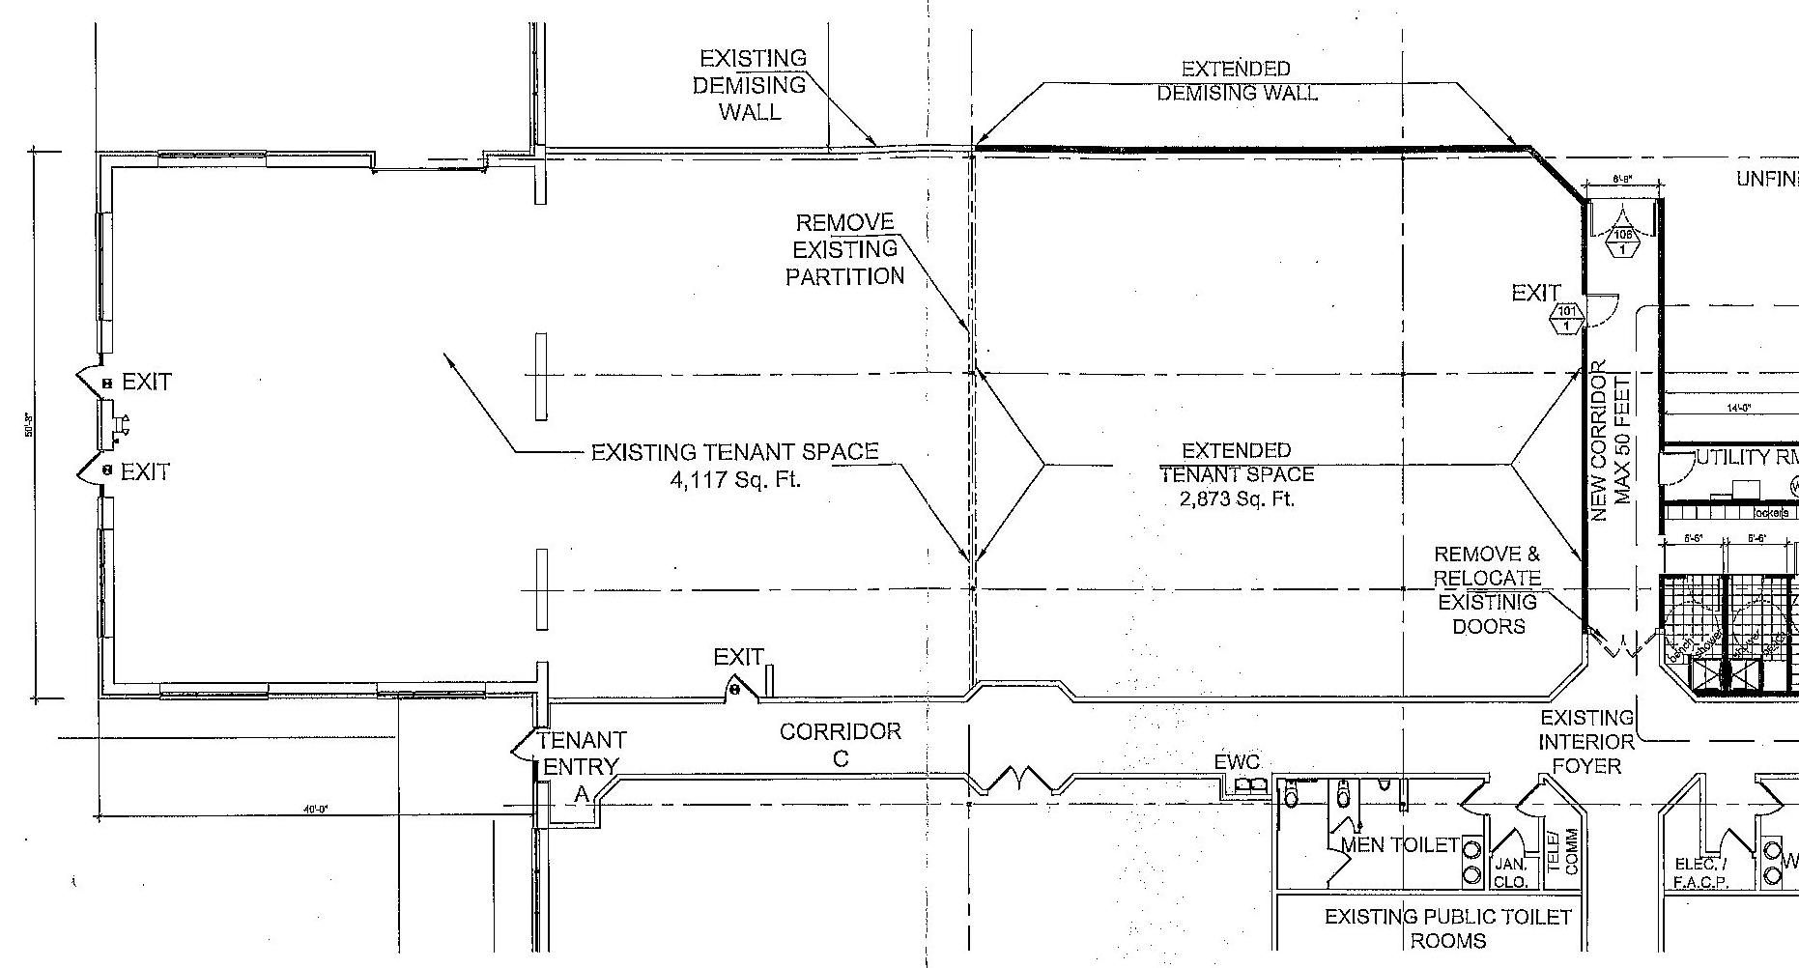
Hartz Building - Suite 110

3,849 SF
Drive-In Door

SUITE 110
3,849 SF

Drive-In
Door

Front of Building

Entrance Doors

All information deemed reliable but not guaranteed.

SUITE 111

Hartz Suite 110 – Photos
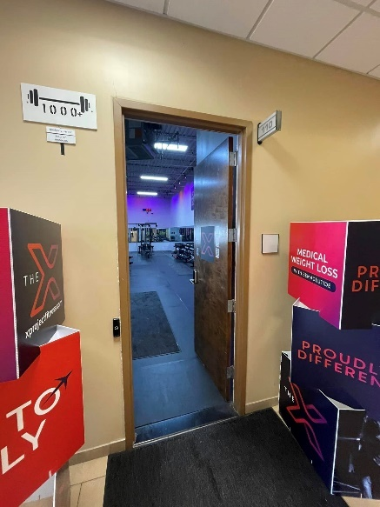
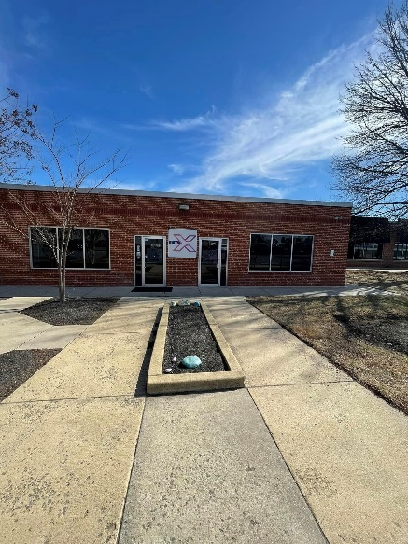
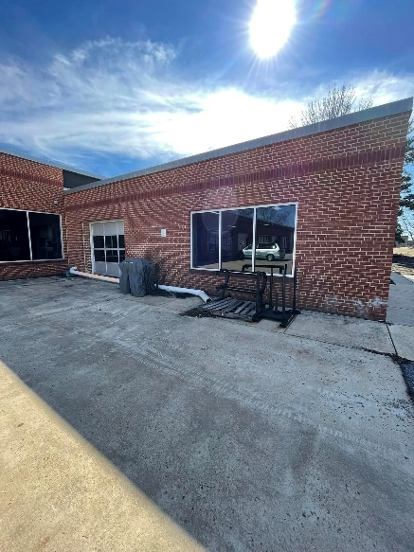

View West Entrance
North Side Drive-In Door
Interior Entrance Door

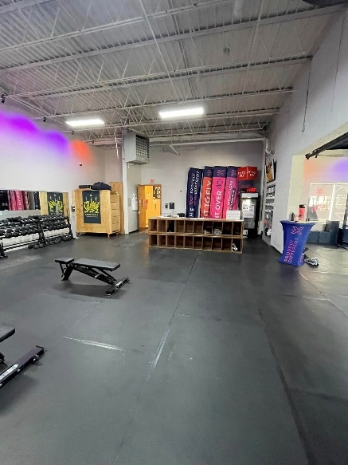
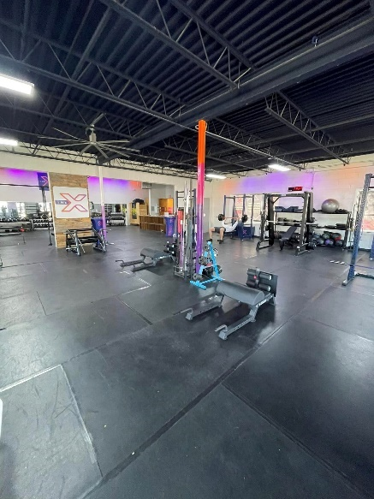
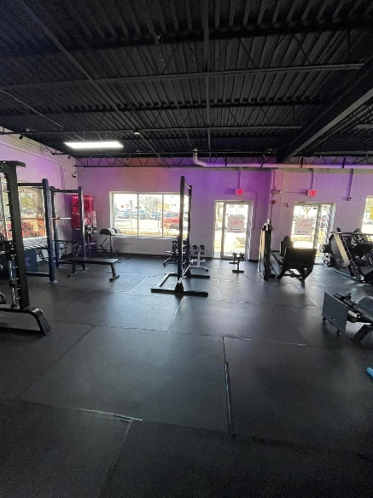

View Reception Desk
Interior View Front Section
Interior View Entrance

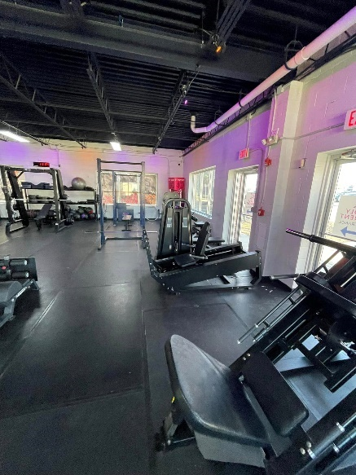
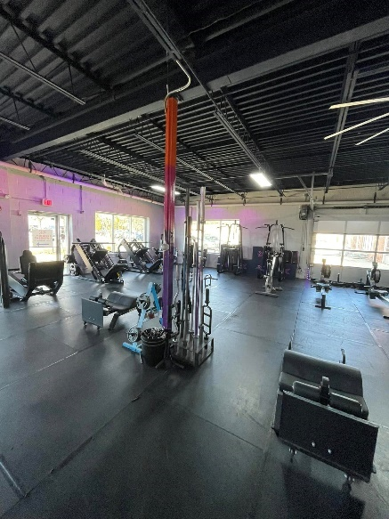
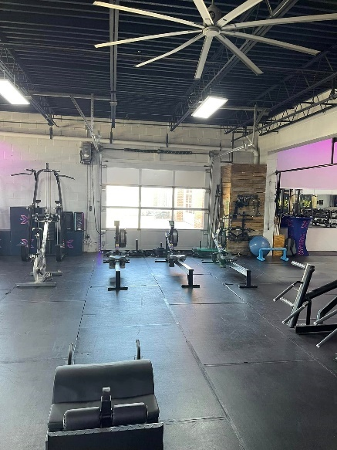

Interior View to South Side
Interior View Northwest Interior View Drive-In

Hartz Building – Zoning

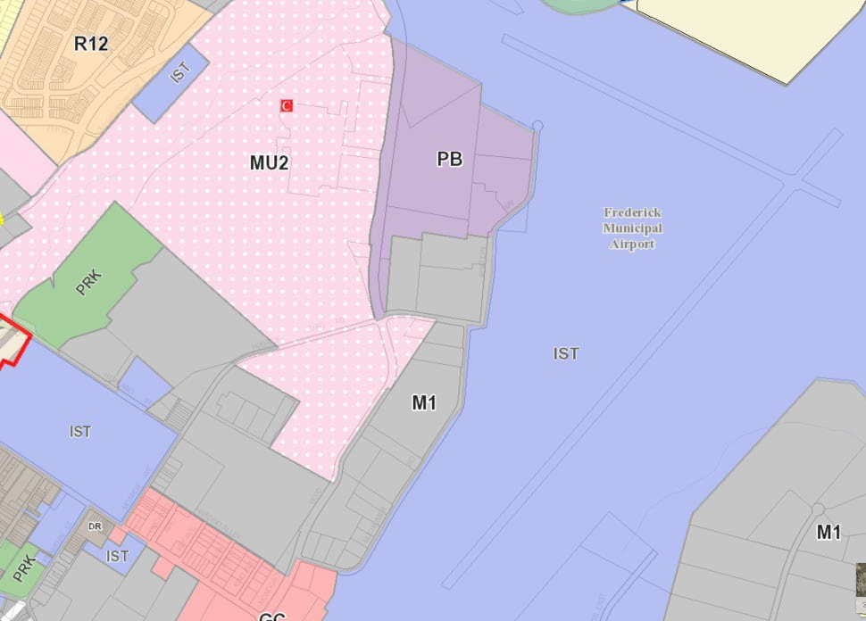
Frederick City
Zoning – Light Industrial (M1)
The M1 district is intended to provide for offices and those industrial activities which do not require special measures to control odor, dust or noise and which do not involve hazardous materials and whose environmental impacts are contained within the property limits. Residential uses are not appropriate for this zone..

P = Some Permitted Uses
- Offices, Business & Professional
- Janitorial Services
- Vehicle Services, Auto Repair Shop Vehicle Services, Truck (1-ton+) Service and Repair Shop
- Truck Sales & Rental (Over 1 ton)
- Animal Care Services (Including Grooming and Boarding) and Commercial kennel
- Automotive Service and Sales
- Vehicle Storage Yards (RVs, etc.) and Storage Yards
- Broadcast and Recording Studio
- Appliance Repair
- Carpenter / Cabinet Maker
- General Building Contractor
- Electrician
- Locksmith
- Plumber
- Roofer
- Sign Contractors and Utility Contractors and Building Tradesman (not otherwise listed)
- Construction Equipment (Sales, Service, and Rental)
- Farm Supplies & Hardware (including landscape, and garden supply sales)
- Farmers Market
- Fertilizer Sales
- Garden center, including sales of trees, shrubs, garden supplies and Fertilizer Sales
- Industrial equipment, plumbing supplies and other heavy consumer goods not otherwise listed, sales and service, with outdoor storage.
- Mobile Homes, Trailers, Recreational Vehicles
- Motorcycles, ATV's, Sales and Repair
- Taxidermy
- Tires, Batteries, Mufflers

All information is deemed reliable but not guaranteed.

Hartz Building Directions:
From the I-70 and I-270 Intersection in Frederick, Drive East on I-70 E. Take Exit 55 toward South St/Fairgrounds. Turn Right onto East South Street. Turn Right at the first cross street onto Monocacy. Turn Right onto Hughes Ford Road to Property on Left at 1481 Hughes Ford Road.

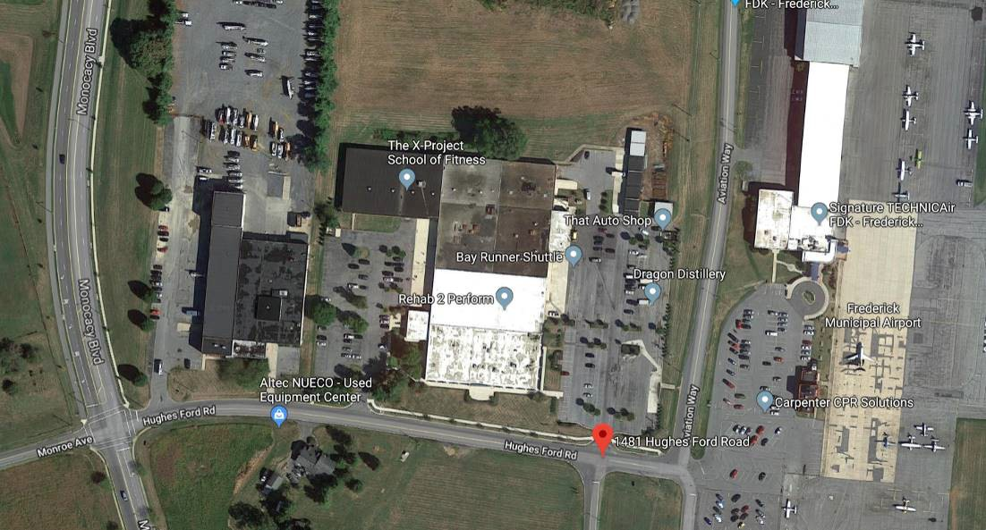
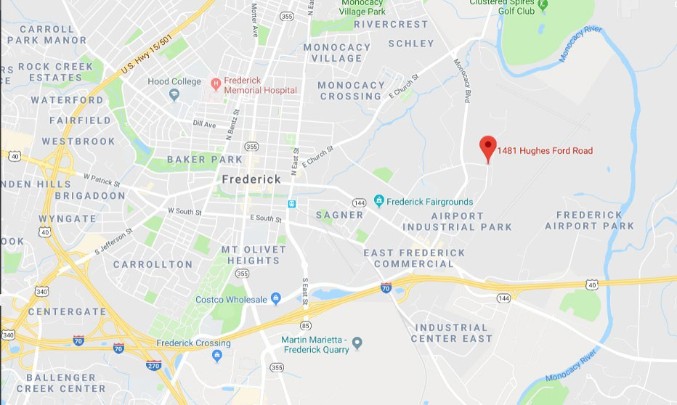
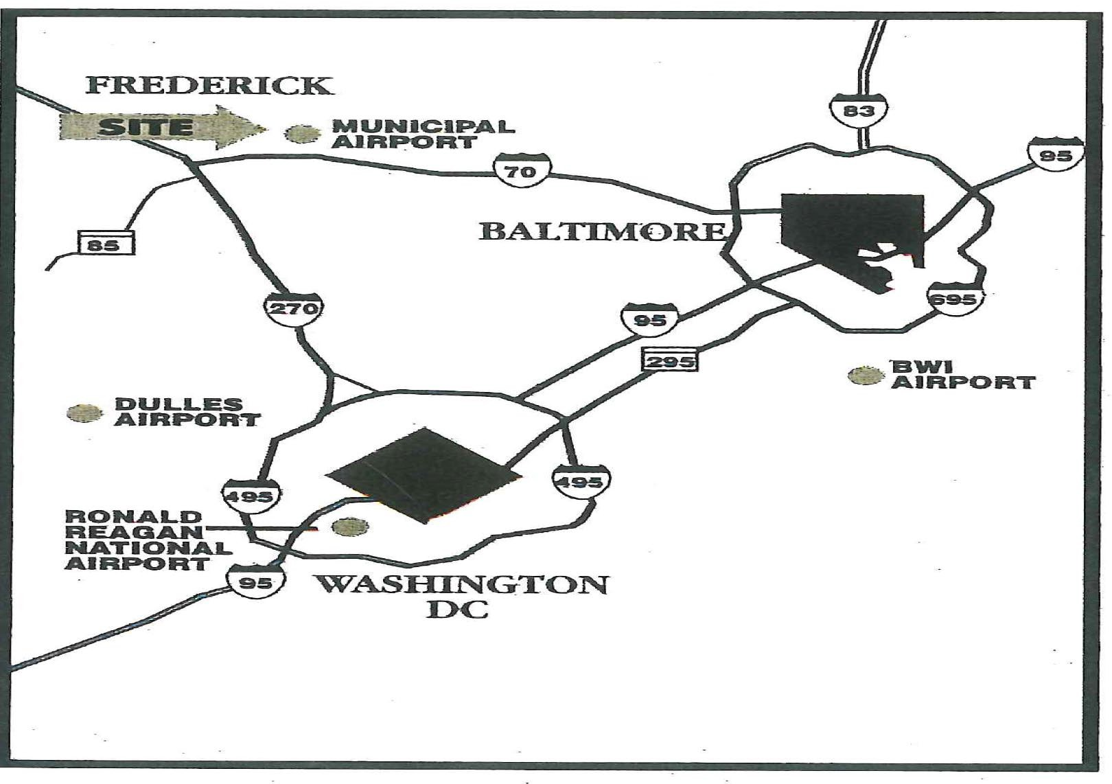
Subject Property

All information deemed reliable, but not guaranteed
FOR ADDITIONAL INFORMATION

CONTACT:

Nancy Green
Call: 301-748-3321
Email: Nancy@NGreen.com

Mackintosh Commercial Brokerage
262 W. Patrick Street Frederick, Maryland 21701 Broker: 1-800-727-SOLD Fax #: 1240-489-7932

