Flavours Of Italy, 887 Green Lanes, London, N21 2QS

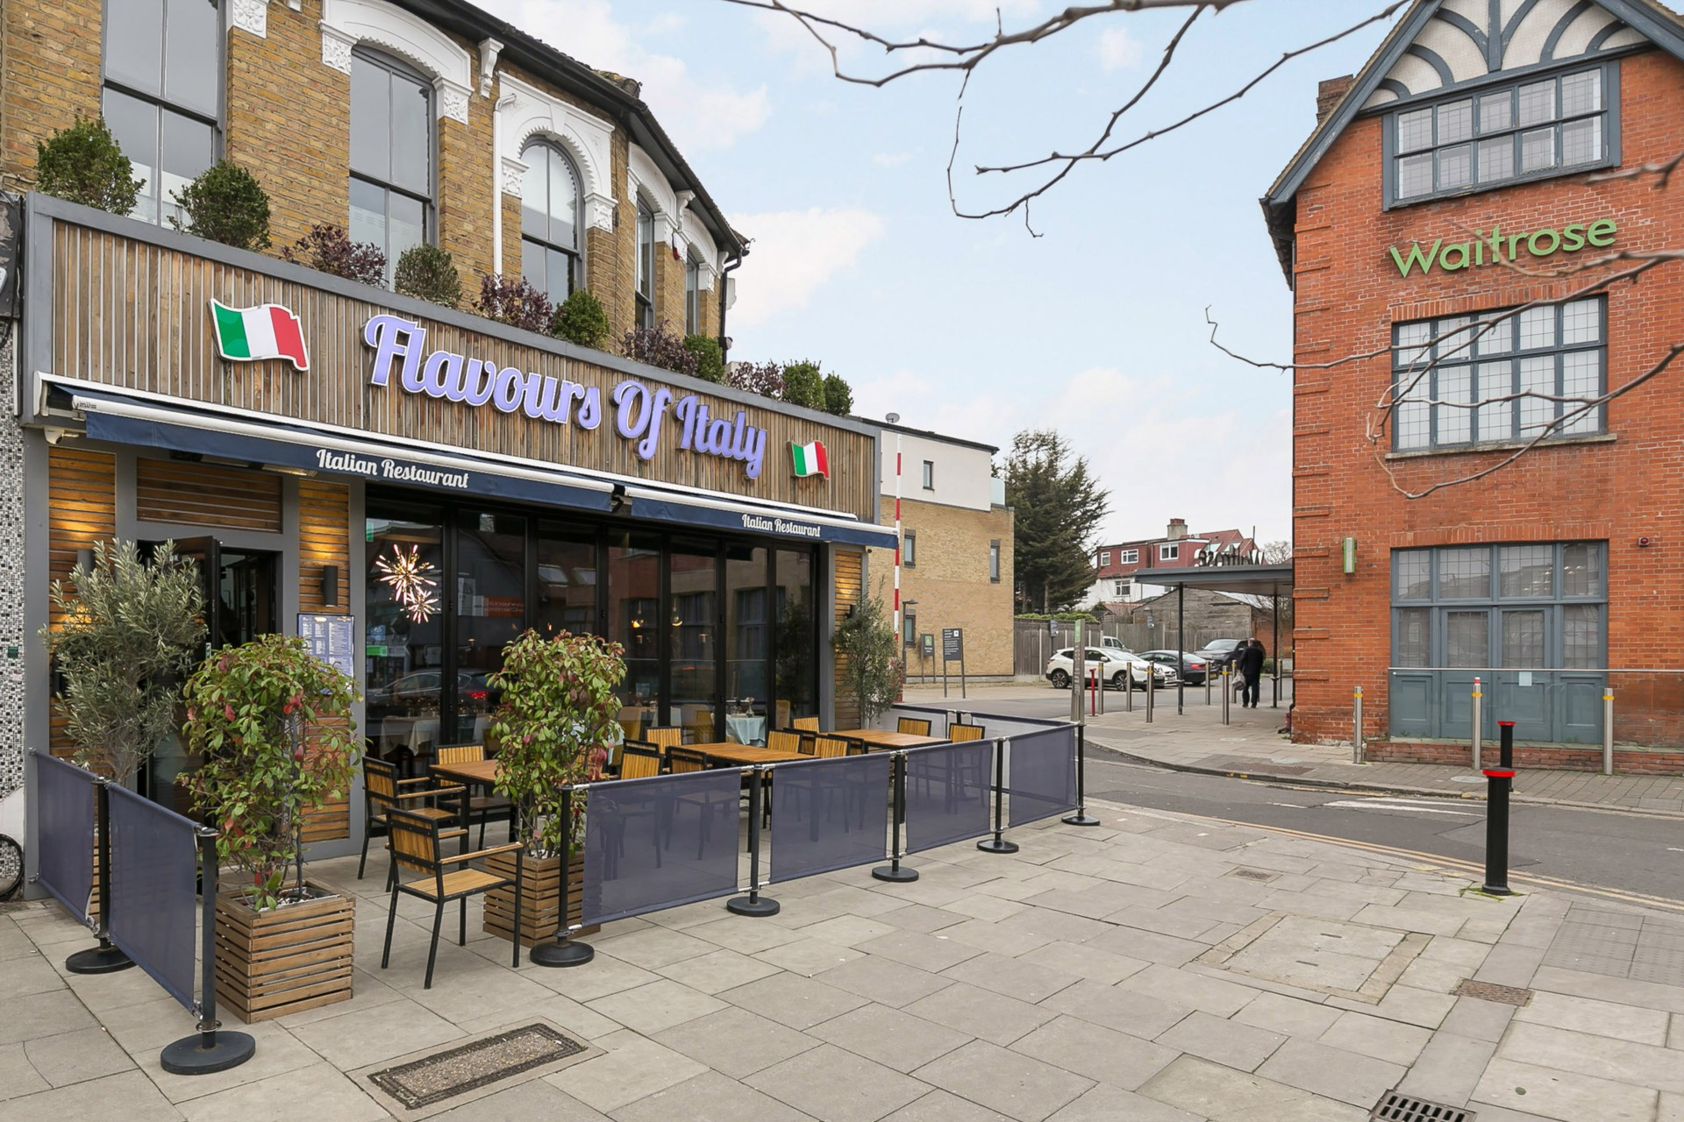

Price £425,000 Leasehold

We are pleased to offer for sale a highly sought-after restaurant located in the heart of Winchmore Hill, on the bustling and vibrant Green Lanes (N21). This well-established and popular business has become a local favourite, with a consistent weekly turnover and a loyal customer base.

- Italian Restaurant  - Split Level Seating  - 2072 sq.ft  - Modern Industrial Kitchen  - 15 Year Lease | - High Road Business  - Well Established Business  - Consistent Turnover  - Private Office  - Two W/C

s
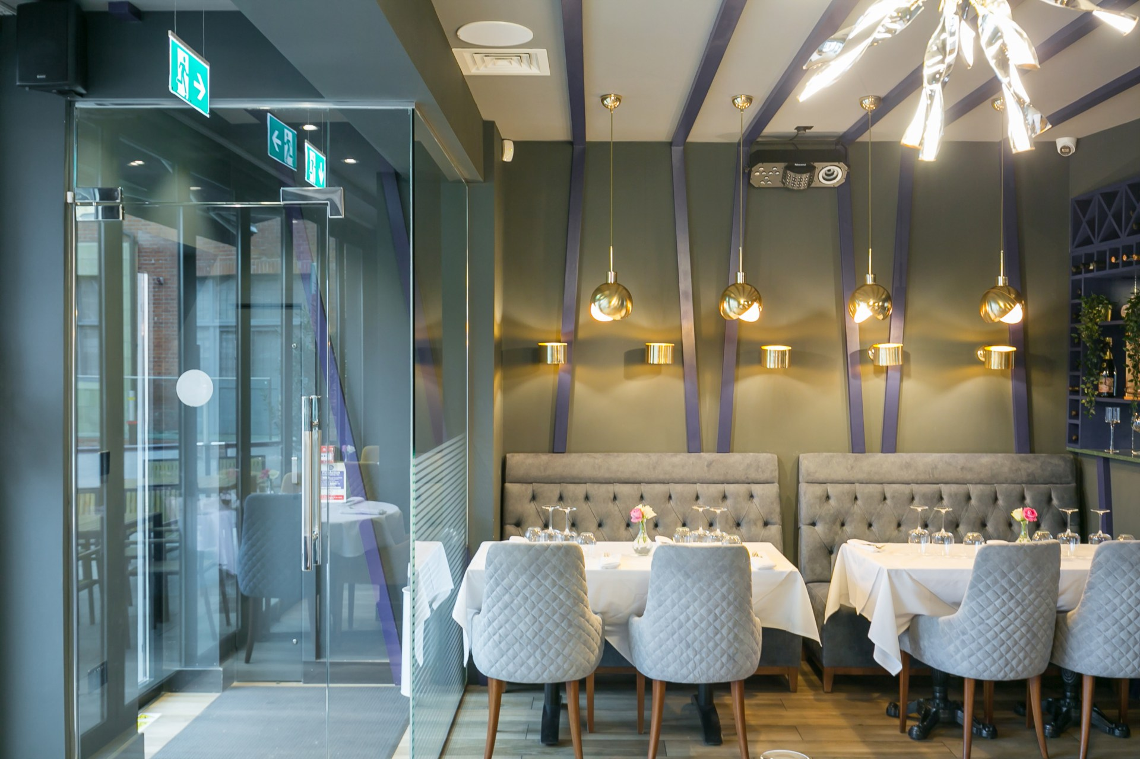

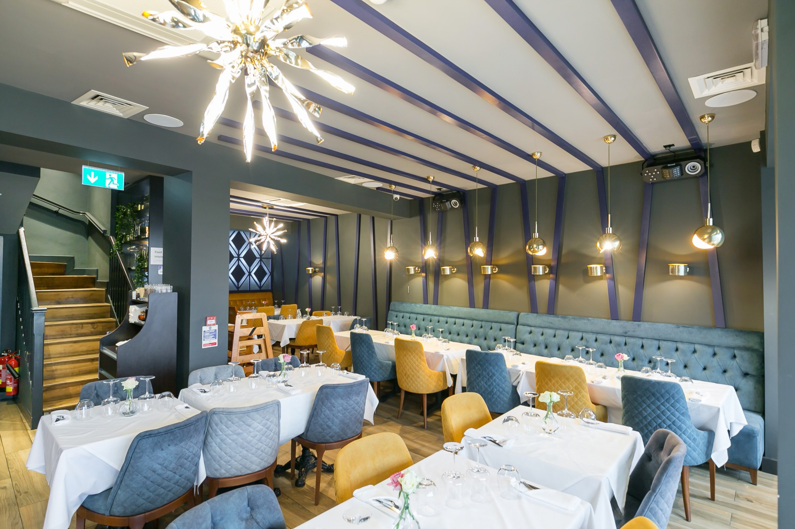

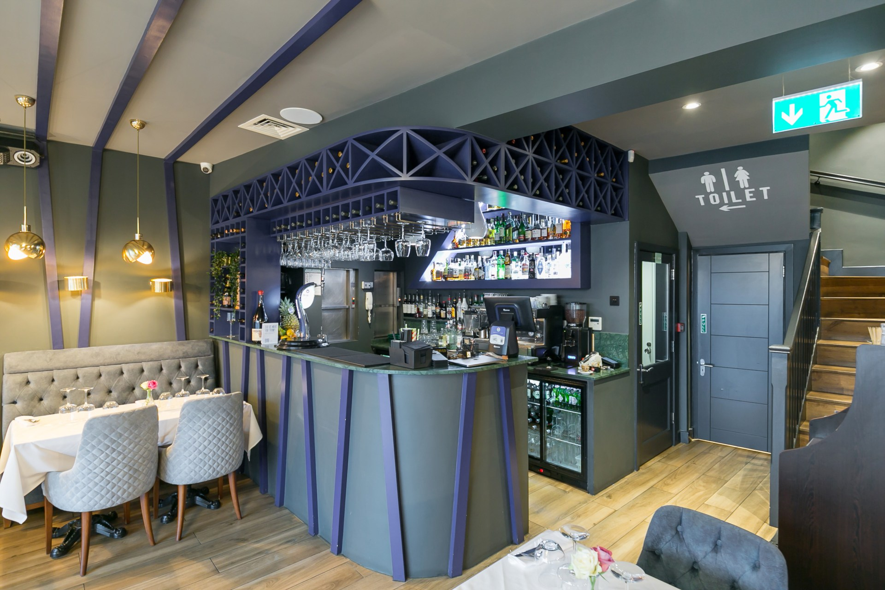

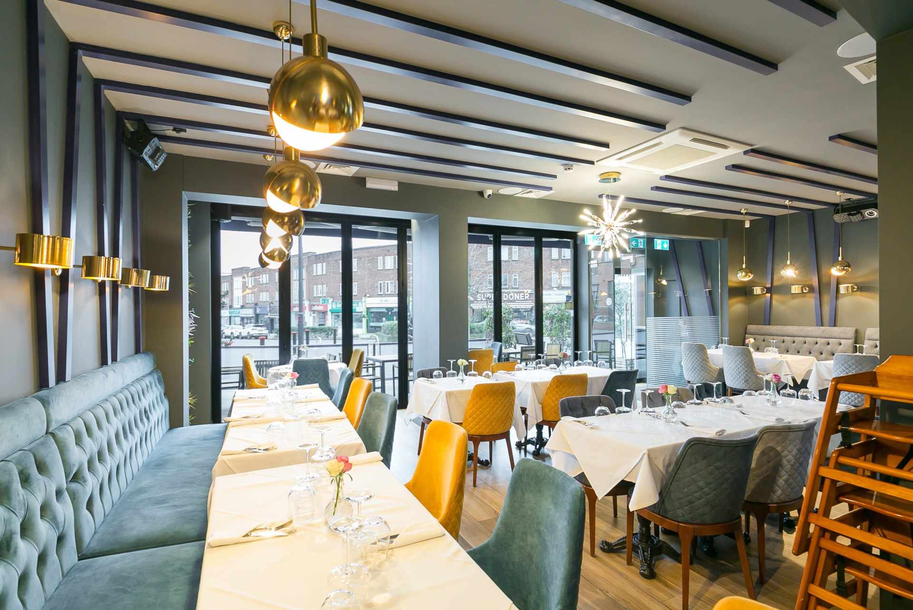

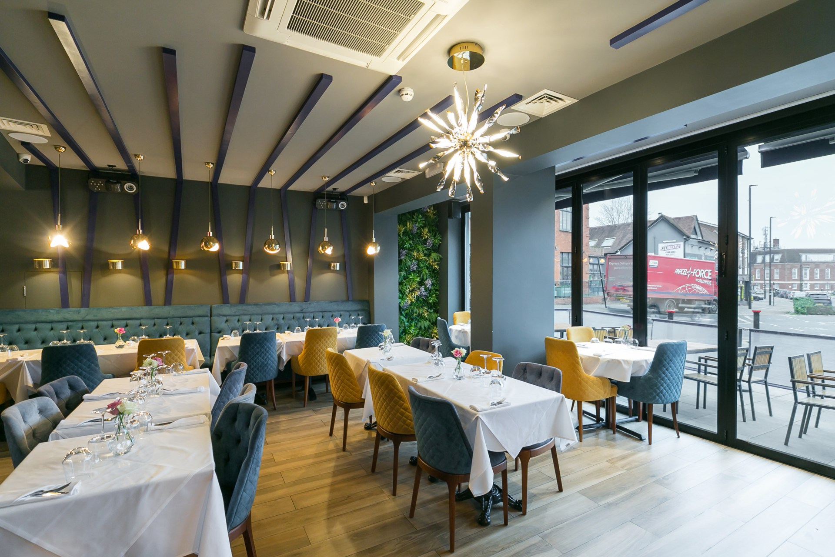

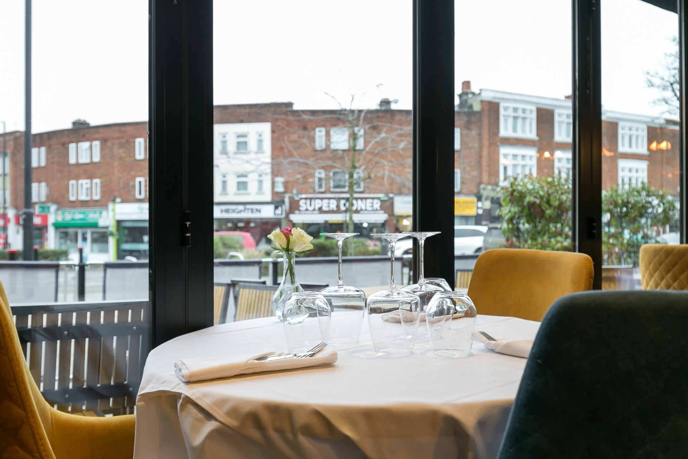

Restaurant Business for Sale - Prime Location in Winchmore Hill (Green Lanes N21)

**Size:** 2072 sq. ft.
**Seating Capacity:** 120 guests
**Price:** [Contact for Price]

Key Features:
- Spacious Layout: The restaurant spans 2072 sq. ft. and boasts a thoughtfully designed interior, featuring both ground floor and first-floor seating areas.
- Seating for 120 Guests: The establishment is spacious and can comfortably accommodate 120 guests, with flexible seating arrangements for a variety of dining experiences.
- Beautiful Design: The restaurant is finished to a high standard throughout, offering an inviting and stylish atmosphere that enhances the overall dining experience.
- Fully Equipped Chef`s Kitchen: The kitchen is fully equipped with professional-grade appliances, making it perfect for a variety of cuisines and high-volume service.
- Functional Bar: A well-designed bar area that adds to the restaurant`s ambiance and serves as a focal point for social gatherings.
- Multiple Storage Areas: The property features ample storage spaces, ensuring smooth operations and easy organisation.
- Outdoor Seating: There is a dedicated outdoor seating area, ideal for al fresco dining and catering to customers looking to enjoy their meal in the fresh air.
- Established Business: This restaurant has been consistently profitable, with a solid weekly turnover and a strong reputation in the community, making it an excellent investment opportunity.
- Prime Location: Situated on the highly desirable Green Lanes, this location benefits from high foot traffic, excellent visibility, and easy accessibility, making it ideal for attracting both locals and visitors.

*Why Invest?
This is a rare opportunity to acquire a thriving, well-established restaurant in one of North London`s most sought-after areas. With its proven track record, prime location, and stylish interiors, this business is poised for continued success.

For further details or to arrange a viewing, please contact us today!

Tenure: Leasehold
Lease: 15 years remaining
Service Charge: £0 per year
Ground Rent: £0 per year
Local Authority: Camden Council
Council tax: To Be Confirmed

SERVICES: It is not our Company policy to test services and domestic appliances, so we cannot verify that they are in working order.

TERMS: We have been advised of the above terms by our Client, but have not seen any documentation to substantiate this information. Should you proceed with the purchase of the property, the details must be verified by your Solicitor.

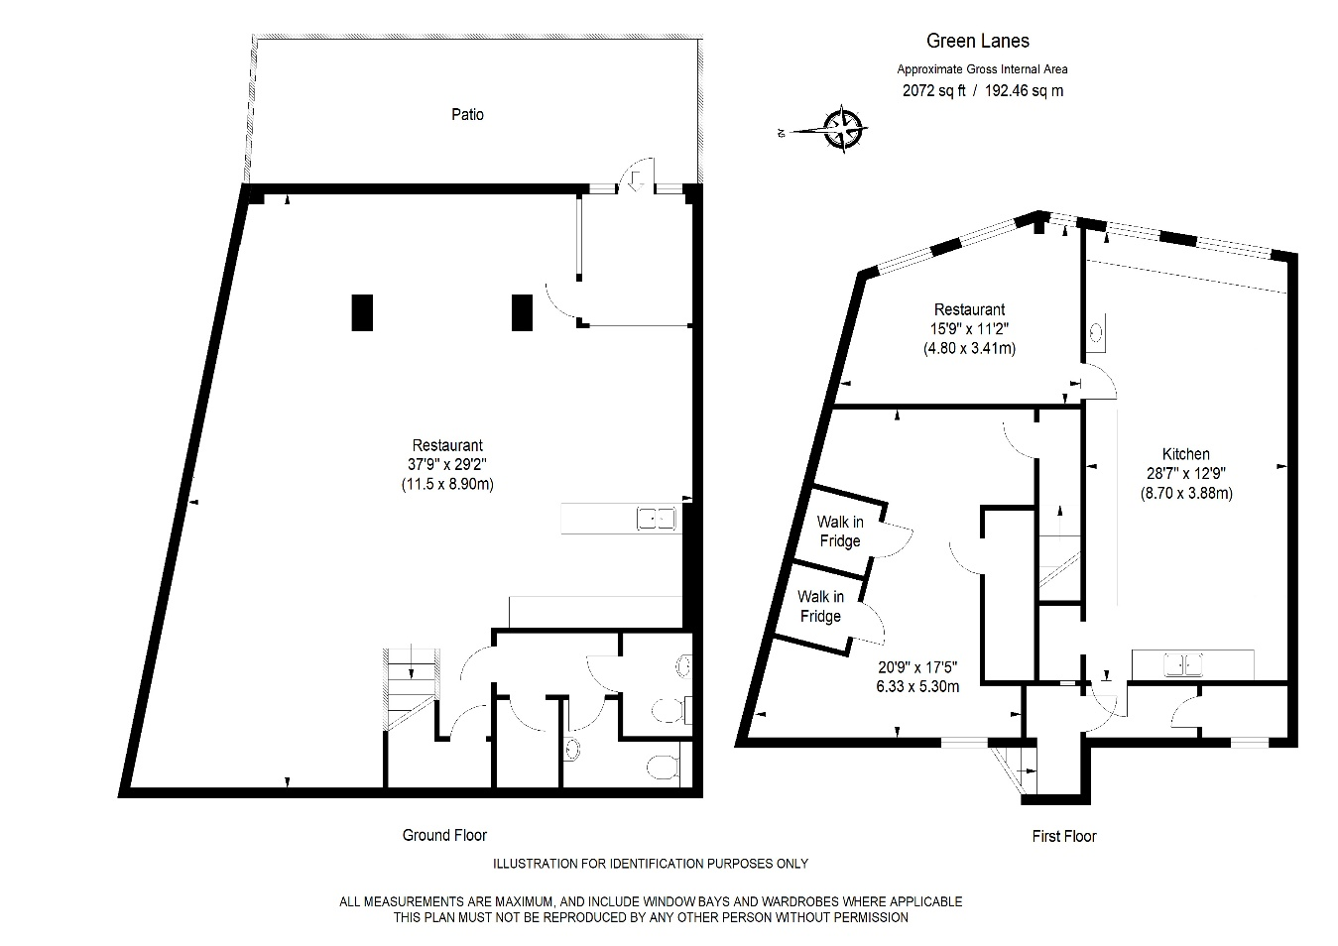
- General: While we endeavour to make our sales and lettings particulars fair, accurate and reliable, they are only a general guide to the property and, accordingly, if there is any point which is of particular importance to you, please contact the office and we will be pleased to check the position for you, especially if you are contemplating travelling some distance to view the property
- Floorplans and Measurements: The measurements indicated are supplied for guidance only and as such must be considered as a guide only.
- Appliances and Services: Please note we have not tested the services or any of the equipment or appliances in this property.

DISCLAIMER:
THESE PARTICULARS ARE ISSUED IN GOOD FAITH BUT DO NOT CONSTITUTE REPRESENTATIONS OF FACT OR FORM PART OF ANY OFFER OR CONTRACT. THE MATTERS REFERRED TO IN THESE PARTICULARS SHOULD BE INDEPENDENTLY VERIFIED BY PROSPECTIVE BUYERS AND TENANTS.

NEITHER CHARLES HENRY PEPPIATT, OR ANY OF ITS EMPLOYEES OR AGENTS HAS ANY AUTHORITY TO MAKE OR GIVE ANY REPRESENTATION OR WARRANTY IN RELATION TO THIS PROPERTY.

