SUBLEASE – Short or Long Term
1420 K Street NW Washington, DC 20005
Full 11th Floor - Suite 1100
5,069 RSF, FS, Furnished, Open Plan & Offices - Plug n’ Play, DISCOUNTED RATE
Available within 30 Days
MARKET
-Great location in East End NW DC
-One Block from McPherson Metro
- Nine minute walk to Farragut Metro
-Walk to multiple hotels, eateries &
amenities

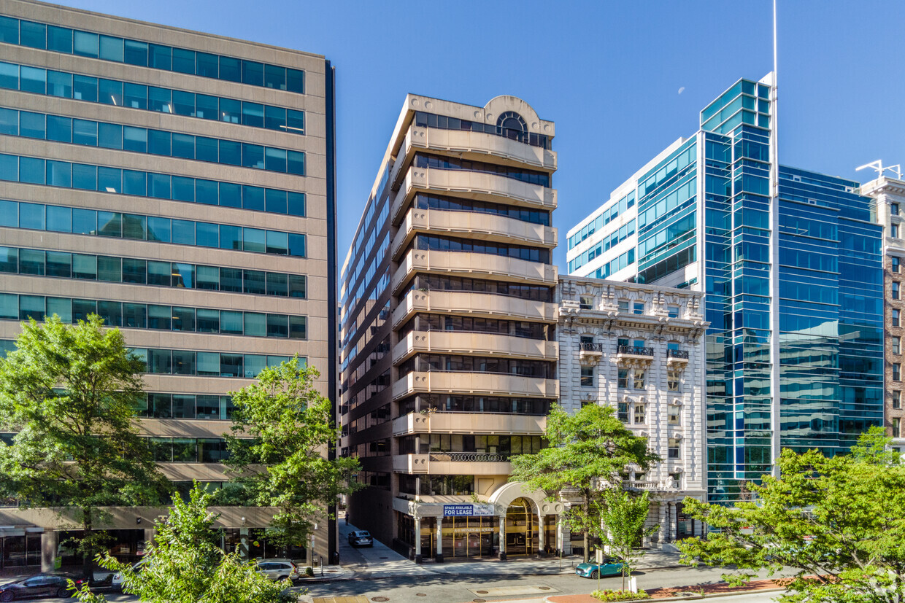
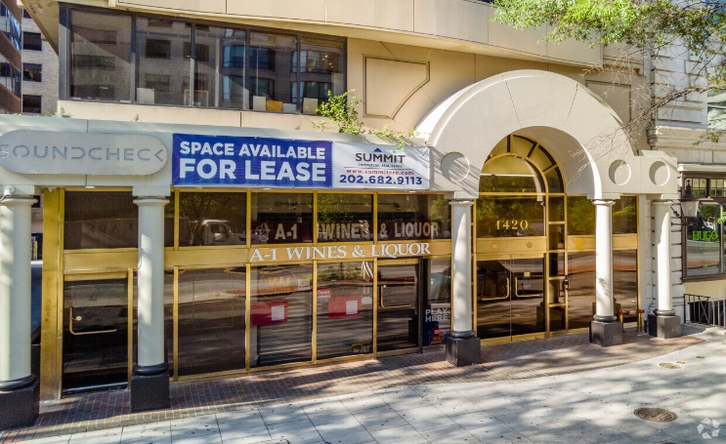
BUILDING
-Renovated Lobby and Common Areas
-Lobby Attendant, Security Suite Access
-Property Management: Empire Leasing
-Parking Available through Landlord
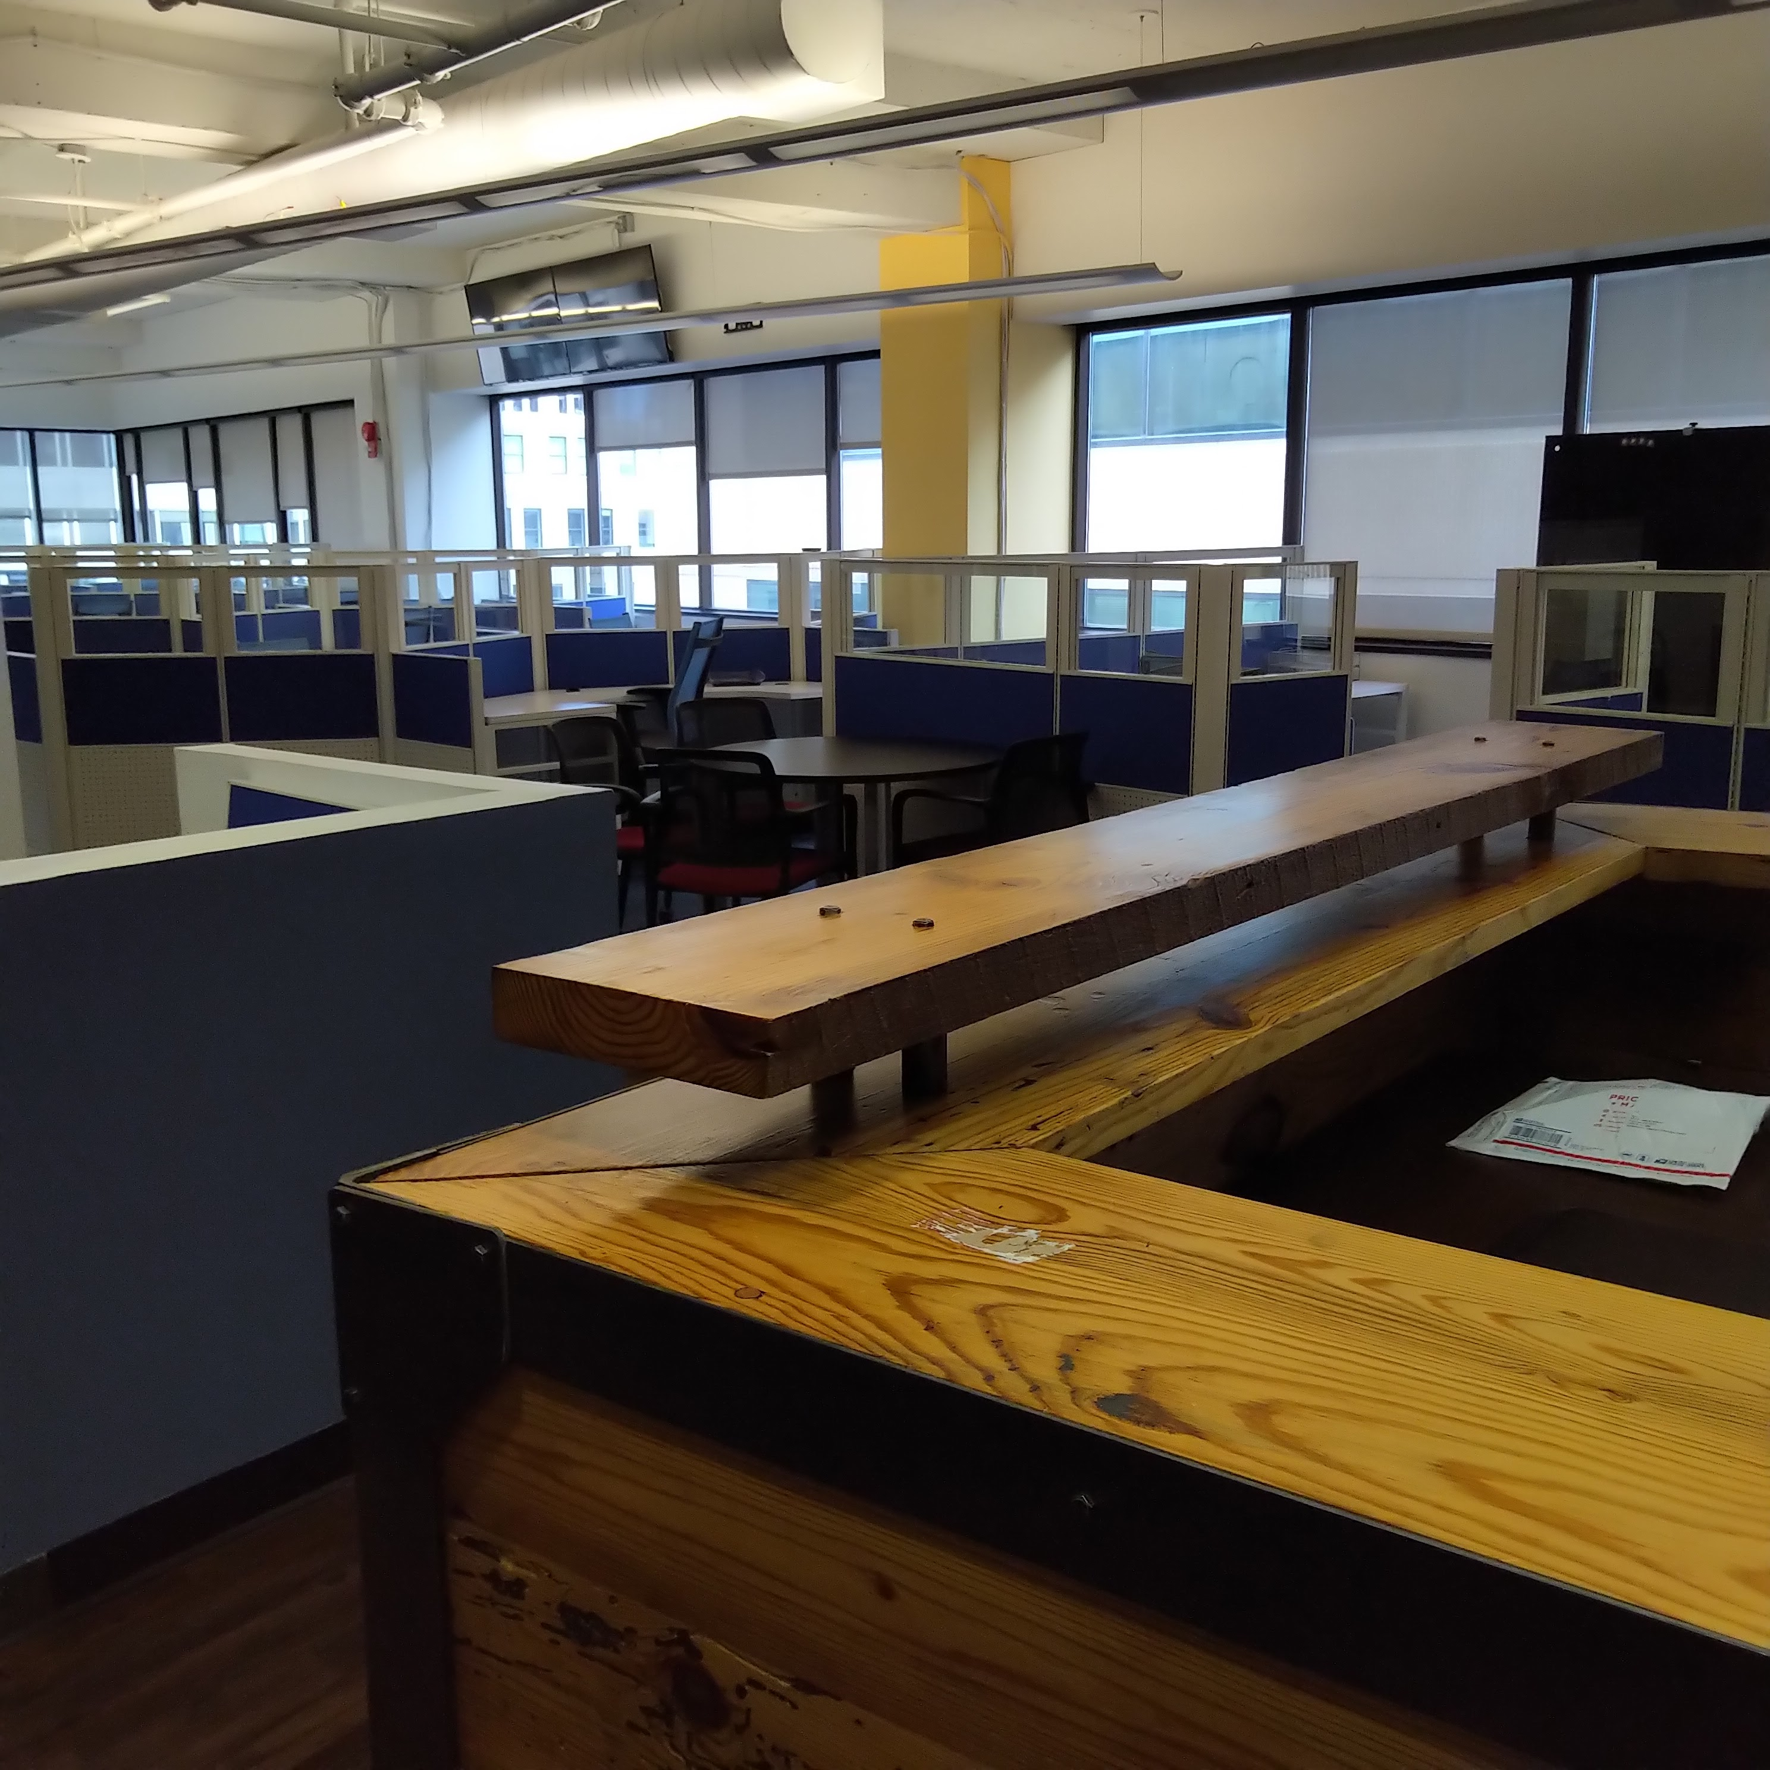

PREMISES
-Rent: $26.00 psf Full Service DISCOUNTED
-Available Immediately
-Annual Escalation: 5% (includes pass- throughs)
-Term: Through May 31, 2029 (or shorter)
-Furnished, Plug ‘n Play
-Three Offices plus 25 + workstations,
-Large Conference Room & LAN Room
-Fully Equipped Kitchen
-Balcony access overlooking K Street
-Solid Sublandlord

For More Information:
Susan Sonley or Westy Kent, Kent Commercial Inc.
ssonley@kentcommercialinc.com or 703-244-2828
SUBLEASE - 1420 K Street NW Washington, DC 20005
Full 11th Floor - Suite 1100
5,069 RSF, FS, Furnished, Open Plan & Three Offices - Plug n’ Play
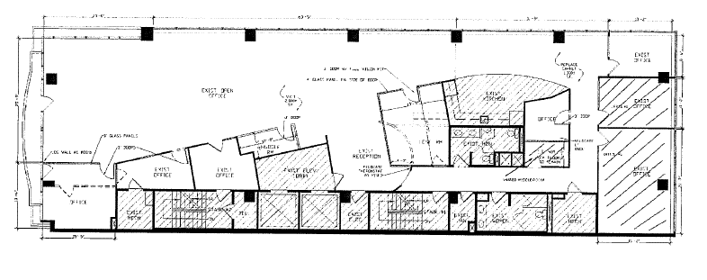
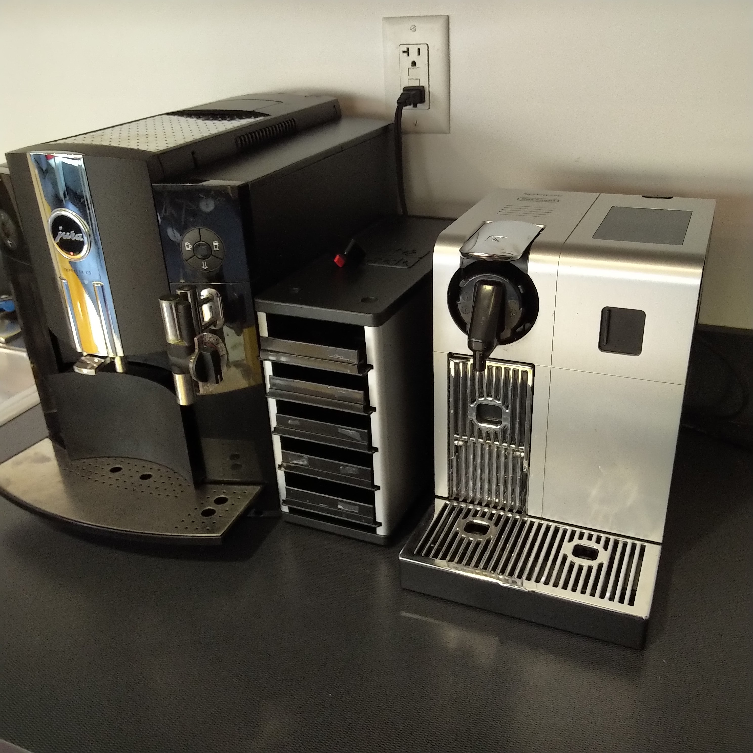
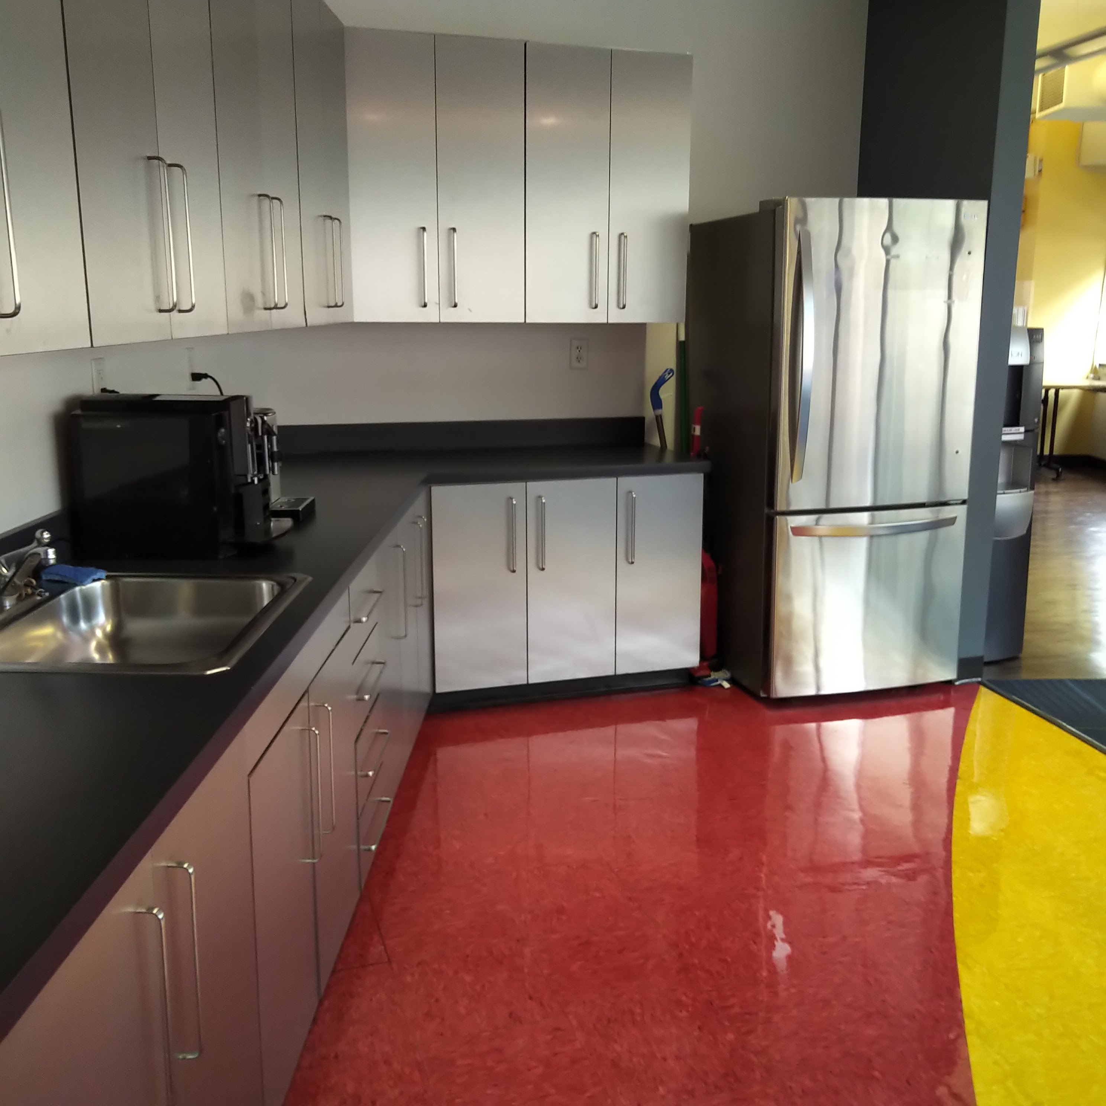
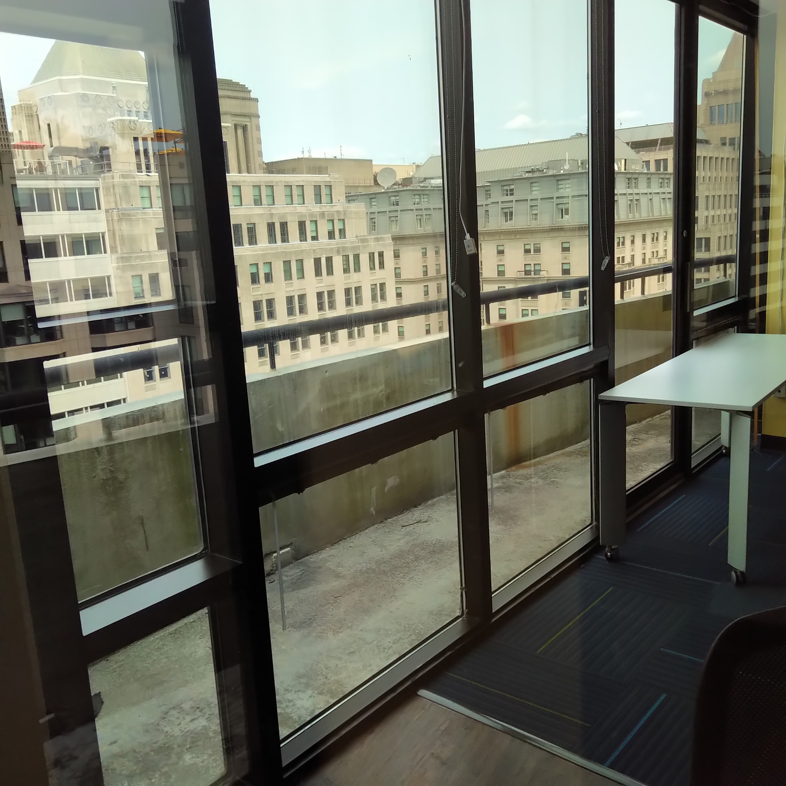
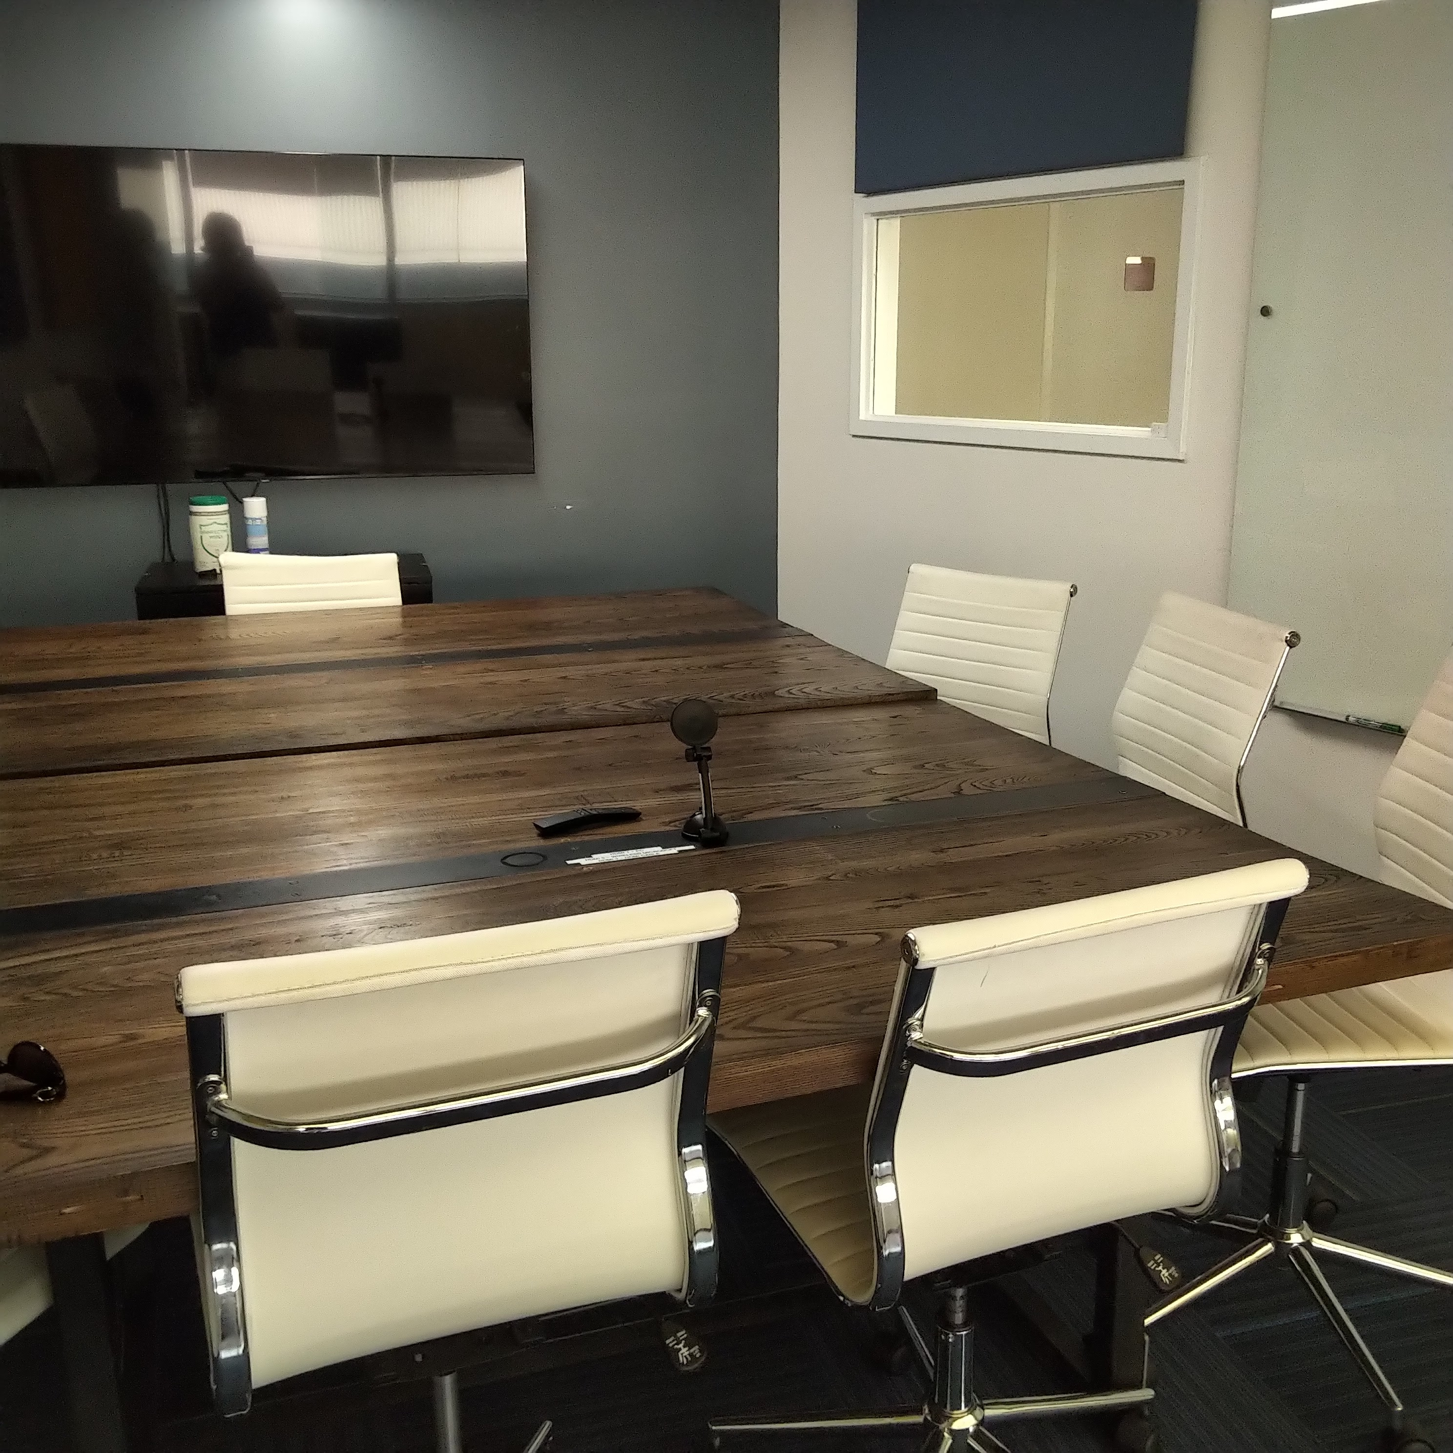
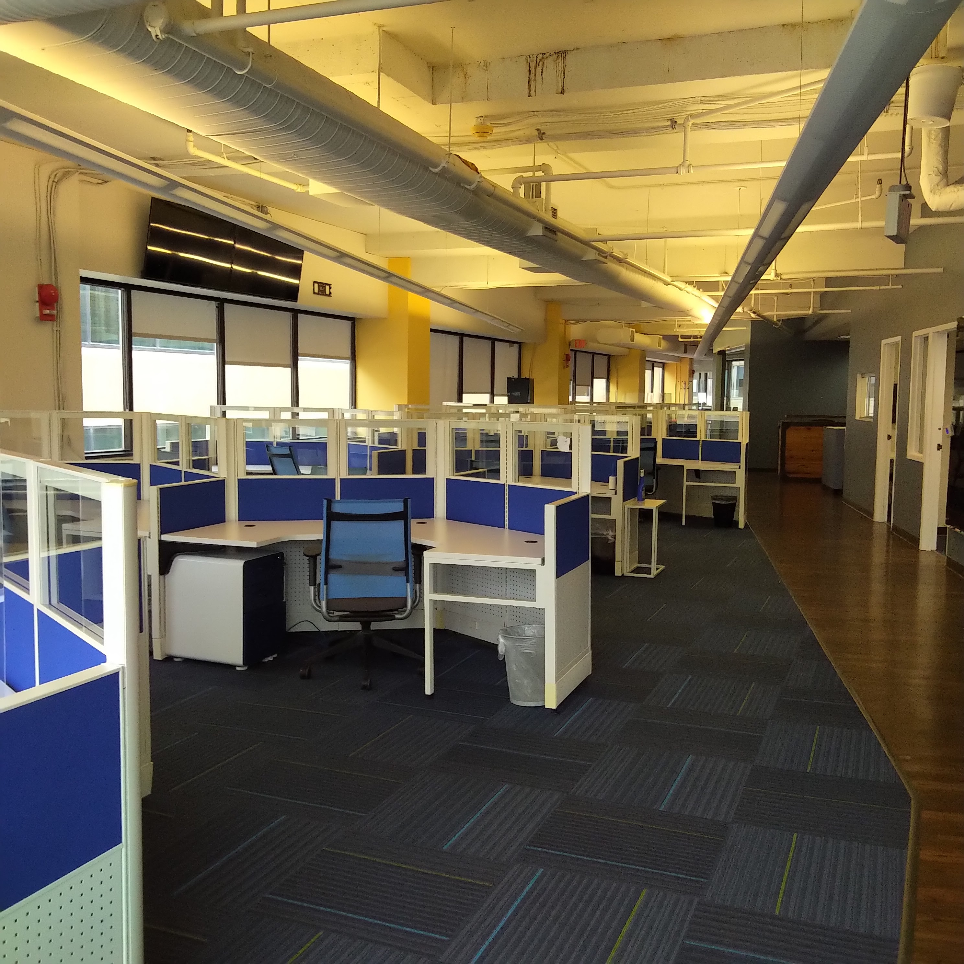
For More Information:
Susan Sonley or Westy Kent, Kent Commercial Inc.
ssonley@kentcommercialinc.com or 703-244-2828

