Full Service Office Space Available
Irondale / Leeds Area
Near I-20 / I-459 Interchange
Side by side- Full-Service Offices
Gambrell Financial Building
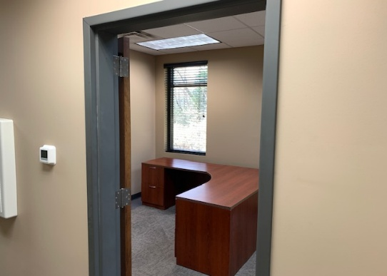
1512 Alex Drive 35210
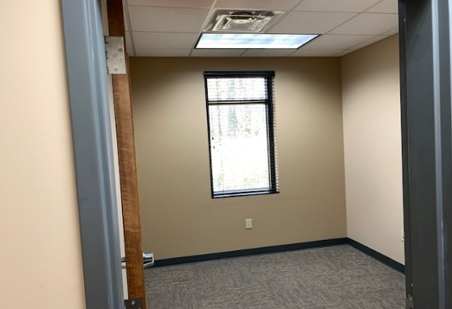

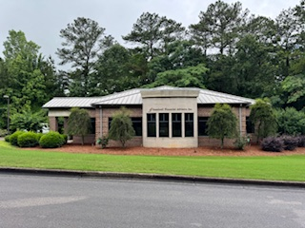

Professional Space Ideal for Attorney, Accountant, Brokers, Financial, etc.

105 s. f. for $322/mo. and 210 s. f. for $644/Mo. One Year lease required.
Discounts for longer term lease.

Shared Reception Area, 2 Conference Rooms, Kitchen, and storage.
One wrap-around desk included.

Ample Parking, Janitorial, maintenance, and all Utilities other than telephone and internet are included in. High Speed Internet available.

Call Dean Gambrell
205-914-8046

