

"Outstanding" Executive Office Space
For Sale
3900 Mechanicsville Rd. Suite # 721
Doylestown, Bucks County, PA 18902

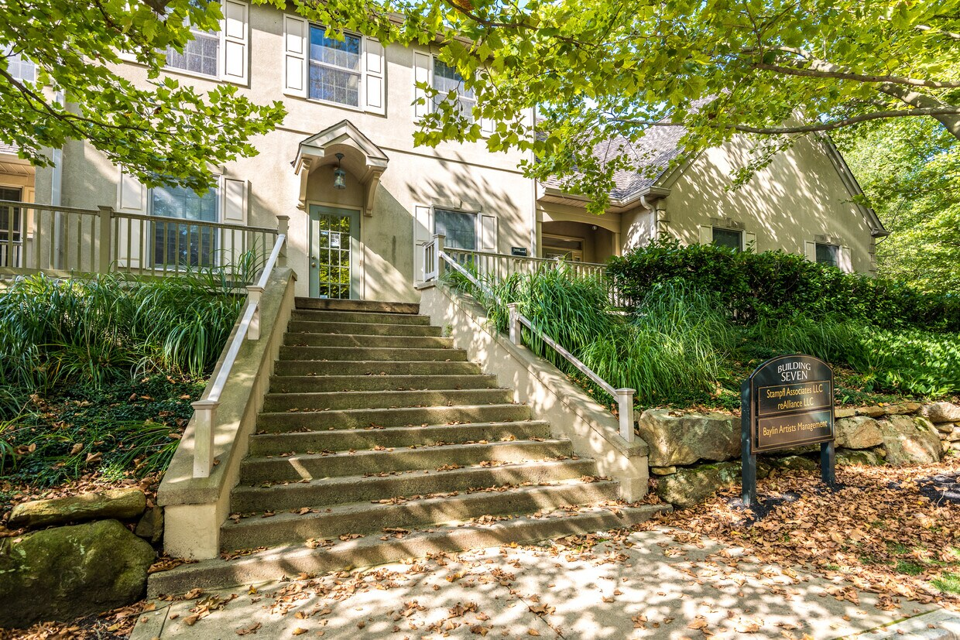

Great location for your local business! The main entry to the building allows for privacy as does the entrance to the unit. The open floor plan has numerous windows which create a bright and airy work environment due to abundant natural light. This renovated space includes three private offices with windows, a spacious open work area, a kitchenette, copy/file area and bathroom. The space is self contained with private main entry & rear egress. Maintenance free and conveniently located in the beautiful Hyde Park office park in Bucks County. Close to downtown Doylestown with Septa Train, County Courthouse, restaurants & accessible to all major commuting routes to Philadelphia, New York & New Jersey. Abundant parking available. Monthly condo fees are $3.50/psft.

Call me for a personal tour, Donna McKenna (215-962-2436) cell



5895 Lower York Road Lahaska, PA 18931 ▪ (888) 482.2666 ▪ (215) 357.2880
www.cbhcommercial.com

No warranty or representation, express or implied, is made as to the accuracy of the information contained herein,
and same is submitted subject to change in price, conditions, omissions, errors, prior sale or rental, or withdraw without notice.

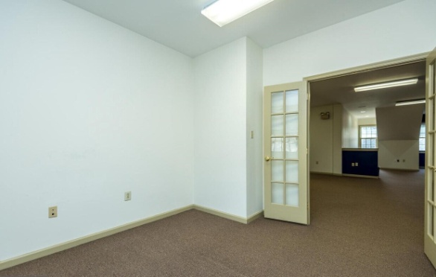
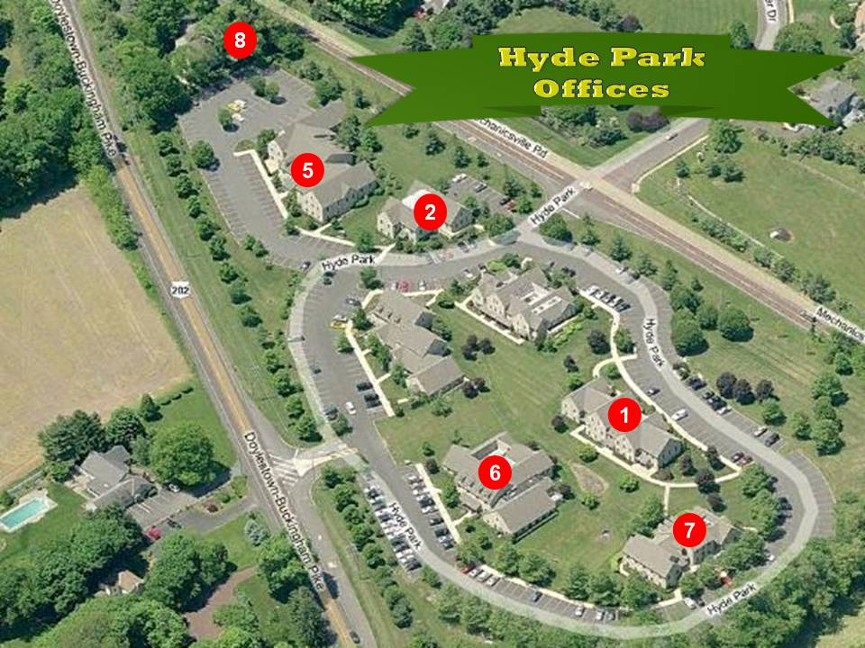
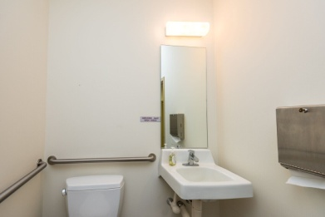
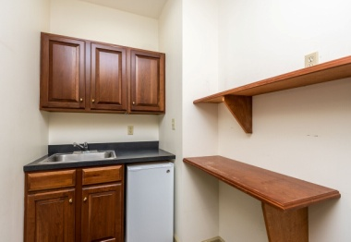
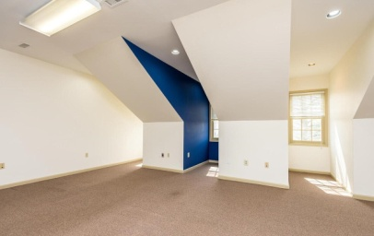
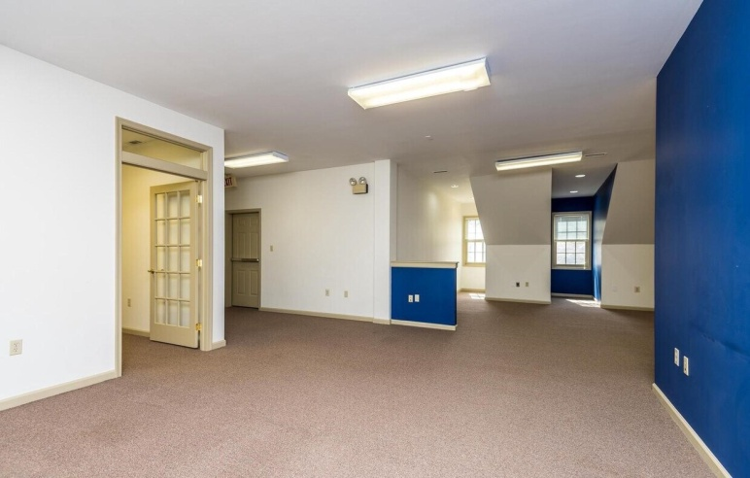
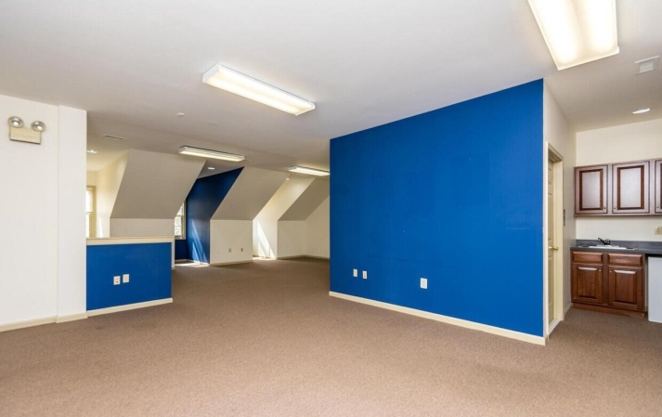
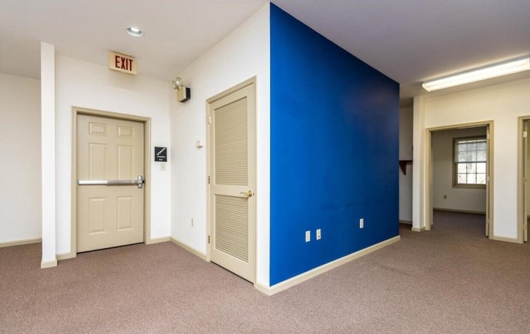
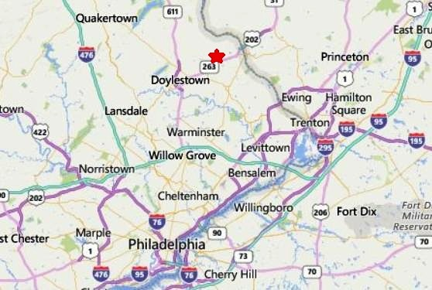
Located in Buckingham Twp., Bucks County PA, with Doylestown mailing address. Less than 50 minutes to Philly, Princeton, NJ.
Lots of windows provide abundance of natural light. Powder room, many architectural features, park like office campus with plenty of parking.

