30,000 SF WAREHOUSE FOR LEASE
PRIME MILWAUKEE RIVERFRONT LOCATION
2217 S. 1st Street Milwaukee, WI 53207
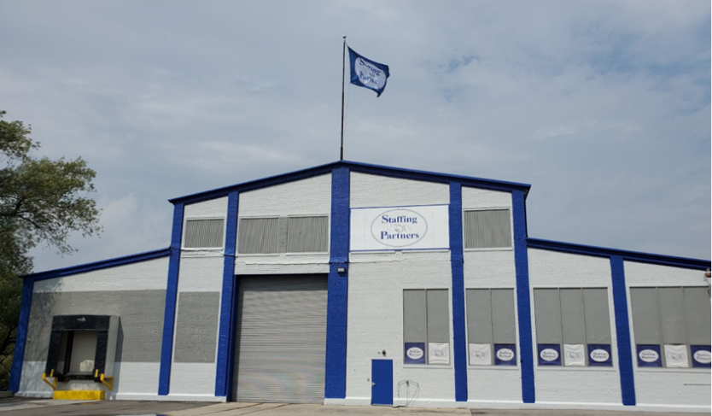
40' VAULTED CEILINGS • NEW CONCRETE FLOORS • NEW LED LIGHTING

✓ 30,000 SF Heated Warehouse | ✓ Milwaukee River Frontage
✓ Warehouse Racking Included | ✓ Shipping & Receiving Area
✓ One Loading Dock | ✓ Two Overhead Doors
✓ Two Offices | ✓ Two Bathrooms + Private Restroom
✓ Bus Line Access | ✓ Minutes from Major Highways
✓ Abundant Natural Light | ✓ Staffing Agency On-Site
Premier Milwaukee Riverfront Warehouse featuring 40' vaulted ceilings, new concrete floors, modern LED lighting, abundant natural light, warehouse racking included, dedicated shipping & receiving area, loading dock, overhead drive-in door, private office space, and immediate access to major highways and public transportation.

Staffing agency located in the adjoining portion of the building, providing convenient access to labor resources for temporary, seasonal, and expanded workforce needs. Ideal for distribution, logistics, manufacturing, warehousing, e-commerce fulfillment, and assembly operations requiring scalable staffing support.

AVAILABLE NOW | MOVE-IN READY

