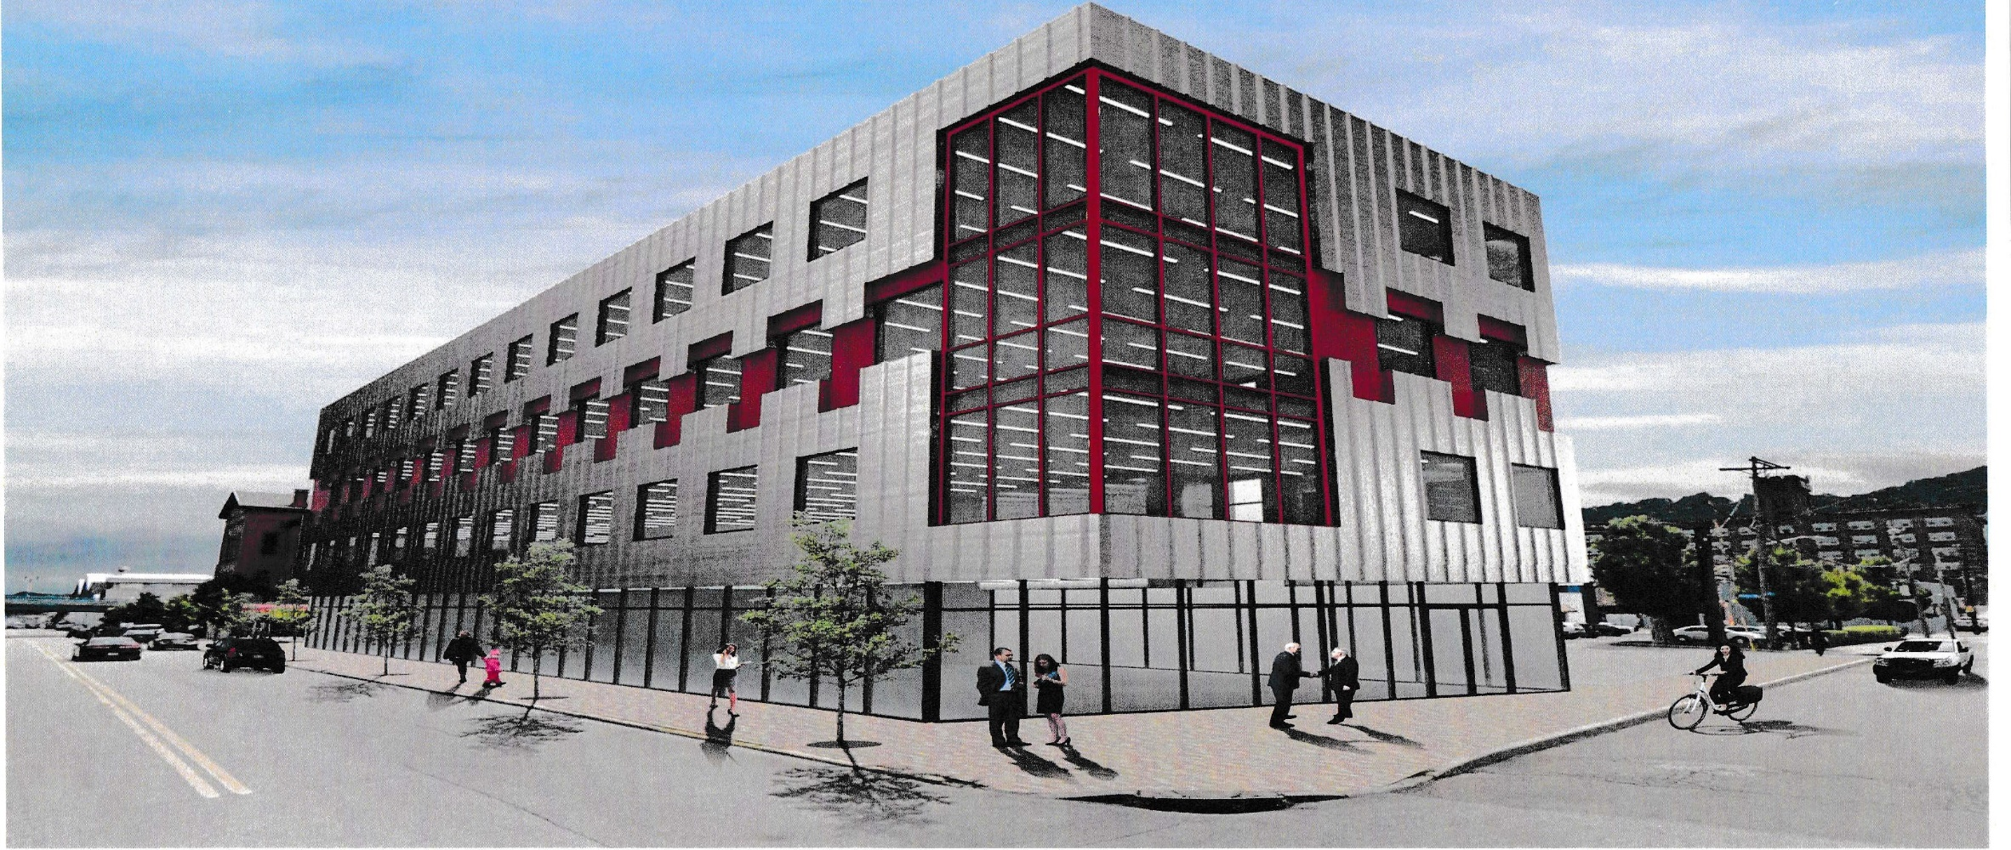
3000 SMALLMAN STREET
STRIP DISTRICT
PITTSBURGH, PENNSYLVANIA

24,000 SQUARE FEET; 6000 SQUARE FEET PER FLOOR; EXCELLENT PARKING
SCHREIBER REAL ESTATE* 5840 ELLSWORTH AVENUE* SUITE 300 * PITTSBURGH, PENNSYLVANIA* (412) 362-5205 EMAIL: BRIAN@SCHREIBERREALESTATE.COM; JOSHUA@SCHREIBERREALESTATE.COM
WWW.WESTPAREALESTATE.COM

