Stanmore Business & Innovation Centre, Stanmore HA7 1GB

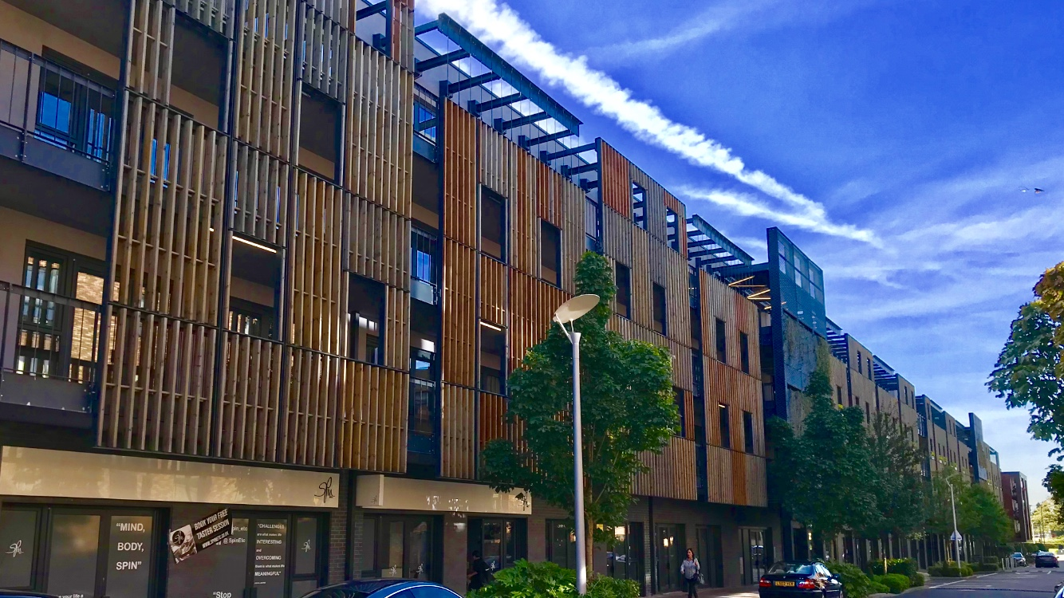

Available Space | Approx size (sq ft) | Desk Recommendation | Price Per Month (ex VAT)
Phase 1:
Suite 107 | 185 | 3-4 | £695
Suite 109 | 445 | 6-8 | £1800
Suite 206 | 445 | 6-8 | £1800
Suite 307 | 185 | 3-4 | £695
Suite 317 | 185 | 3-4 | £695
Suite 318 | 187 | 3-4 | £695
Phase 2:
Suite 1002 | 350 | 6-7 | £1315
Suite 1003&4 | 1214 | 16-18 | 4550
Suite 2001A | 350 | 6-7 | £1315
Suite 2003 | 350 | 6-7 | £1315
Suite 2004 | 835 | 14-16 | £3150
Suite 102 | 351 | 6-7 | £1315
Suite 201B | 350 | 6-7 | £1315
Suite 202B | 350 | 6-7 | £1315
Suite 203A | 350 | 6-7 | £1315
Suite 204A | 350 | 6-7 | £1315
Suite 204B | 350 | 6-7 | £1350
Phase 3:
Retail Unit 3 | 1219 | Retail Unit (Café) | £4575

Description: Stanmore Business & Innovation Centre is a thriving business center with a variety of large open plan spaces and smaller cellular offices. We provide support to our tenants and facilitate the growth of their businesses whether it be making tenants aware of local funding that might be available to them or inviting the tenants to a networking event.

Transport: We are a 2-minute walk from Canons Park tube station which is 3 stops from Wembley Park and provides excellent transport links to central London via the Jubilee Line.

What does the above price include?
- Rent
- Service & Maintenance Charges
- Communal cleaning

Additional Costs
- Super-fast fiber Internet, as per requirement
- Business rates are not included although many offices should qualify for 100% rates relief but please rely on your own enquiries.
- Furniture can be arranged at a cost.
- Meeting rooms available to hire.

Building Features
- Unfurnished
- Modern build

